Log into BT SMS as normal.
On the front screen click on home.

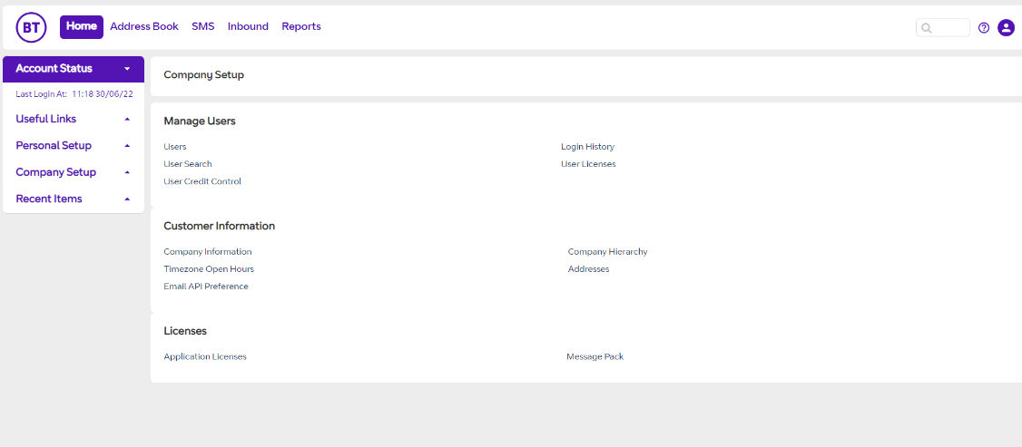

Select Dashboard from tabs
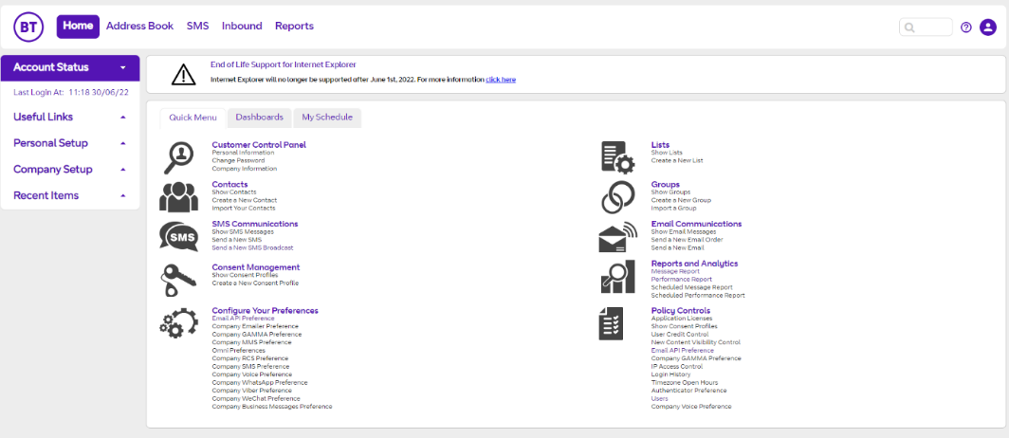

When the dashboard opens, scroll down to the bottom until you reach Send SMS.
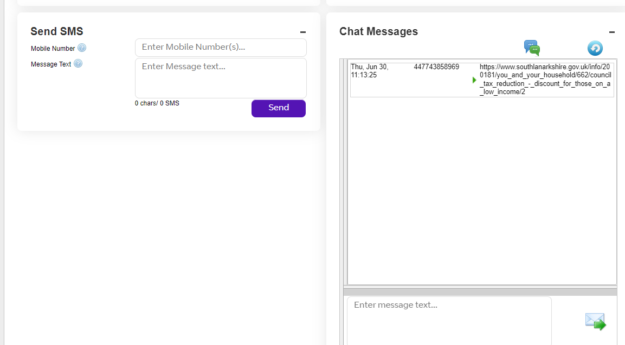
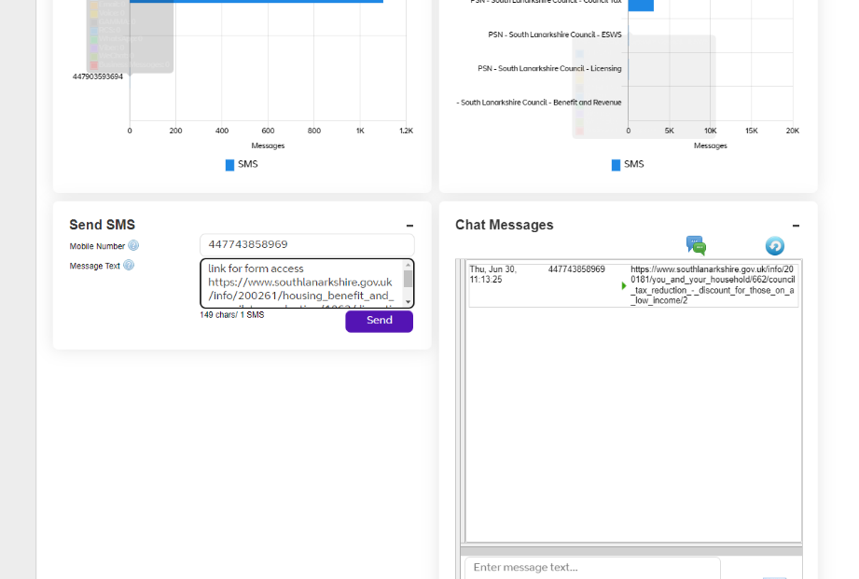
Enter mobile number here
Copy and paste link from webpage to here or enter text
Click send for message to be delivered

When adding a link to the quick message, I suggest that you link to the content page rather than direct to the form. This will allow the customer to read any information relating to possible evidence requirements or criteria.
