

Finance and Corporate Resources
Finance Services

Title: Universal Credit changes and CTR

Date written: June 2024 Last Reviewed: March 2026

Review date: April 2027 Version: 26.01

Contents Page

1. Introduction 2
2. Notification of UC changes 2-3
3. Updating UC details on the benefit claim 4-5
4. Household changes 6
5. Claimant and partner changes 6-11
6. Dependent children 11-18
7. Non-dependant moves in or out of household 18-20
8. UC payment transactions 20
9. Earned income and childcare costs 20-21
10. Self-employed income 21-22
11. Unearned income 22
12. Assumed Yield Capital 23
13. Transitional Protection 23
14. Changes to allowances/elements 24
15. UC award and Benefit Cap 24-25
16. UC report shows change of address 25-26
17. Claimant does not qualify for CTR 27
18. UC non qualifiers and Housing Benefit 27
19. Further Information 28

Record of amendments 29-30

1. Introduction

1.1 This procedure details how to process Universal Credit changes for Council Tax Reduction (CTR) that are received from the Department for Work and Pensions (DWP).

1.2 For UC terminations, please refer to the UC terminations and CTR procedure.

2. Notification of UC changes

2.1 All UC changes are received from DWP through the UCDS files where there is a CTR interest registered.

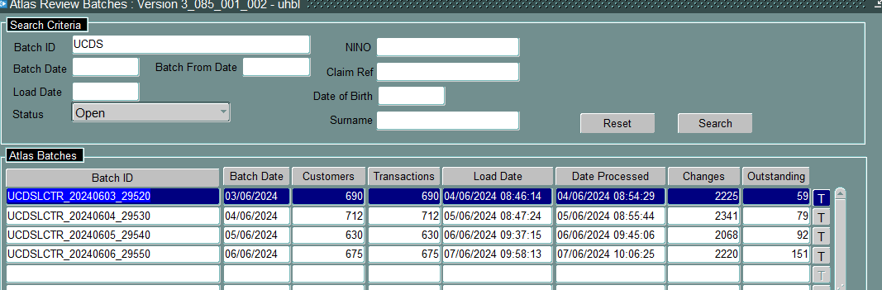

2.2 DWP will send local authorities the following:

- UC New Claim details i.e. New LCTR Claim
This is the first set of data that will be sent to us once DWP has verified the claimant’s ID. Any information shared at this point has not been verified by DWP. As a result, any information on the UC new claims report should not be used to assess CTR.
- First UC assessment payment details
At the end of the first UC assessment period, DWP will share the new claim payment details with us and at this point, the information has been verified.
- If there is a change to the original claim data received, the UCDS report with give full claim details again (correct details this time). This is the information that should be used when processing the CTR claim.
- If there is no change to the original claim data received, the UCDS report will only give the payment details.
- Change in circumstances data share
Once a UC claim is established, we will receive a UCDS payment transaction each time there is a change to either the claim or payment data for that claimant. If there is no change, no UCDS transaction will be received.

2.3 A transaction is generated for each UC assessment period that the claimant has a change to their UC. These changes can include:

- Household changes
- Changes in earnings, unearned income and tariff income
- Changes in address
- Changes in Housing Costs

2. Notification of UC changes (cont/d)

2.4 The UC transactions work similar to Atlas where they can either be auto-updated, ignored, proposed or manually updated.

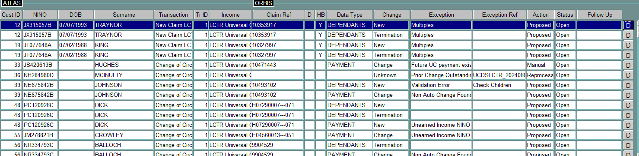

NB: There can be more than one change within the UC transaction e.g. UC award affects more than one claim, household and payment change.

2.5 Auto-Updated Transactions
A UC transaction will be automatically updated by the system where there are no changes to the claimant’s UC award.

2.6 Ignored Transactions
A UC transaction will be ignored if there is no HBCTR claim on the benefit system for that claimant.

2.7 Manual Transactions
Manual transactions normally mean that UC have amended a claimant’s UC award for a past period and these changes are required to be manually.

2.8 Proposed Transactions
The system will propose a UC transaction when there are changes to the UC award that may have an impact on the CTR claim. These transactions should be checked to ensure all details are correct on the system before accepting.

If you are unsure what changes have been proposed on the system, you can click on ‘pre-update’ which will show you what the screen looked like before the UC transaction was received. This can help identify the change that has occurred.

Pre-update
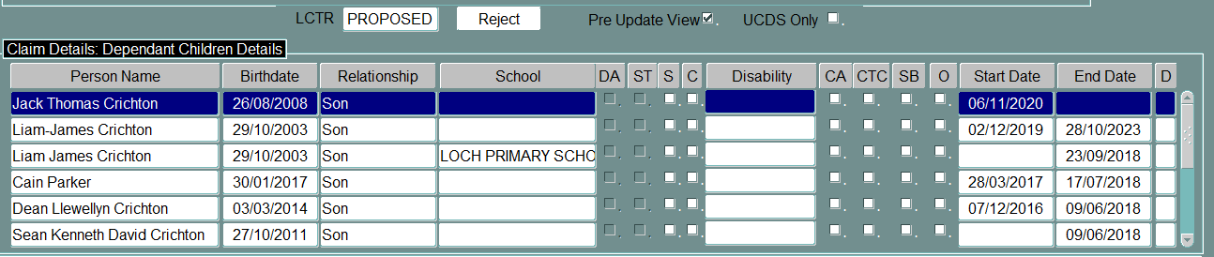

UC proposed changes
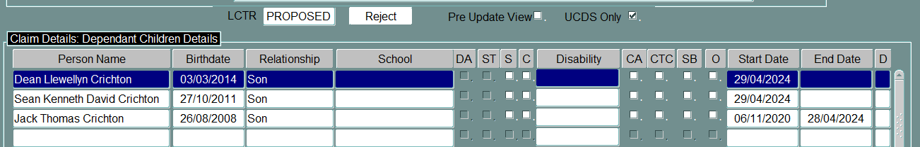

2.9 When we receive notification of a change that requires to be updated on the benefit claim, all household, income and capital should be checked to ensure CTR is calculated correctly.
3. Updating the UC details on the benefit claim

3.1 When a UCDS file is received, all transactions that have a HB award (temporary and specified accommodation) must be prioritised. If HB is in payment, there is an auto-suspend applied and this will allow the suspension to be lifted before the next HB calculation.

3.2 You can filter so that it only shows those transactions that have HB involvement. In ‘HB Claims’, select ‘HB’ or to move all HB transactions to the top, you can click on the ‘HB’ box so the claims with a ‘Y’ appear at the top.

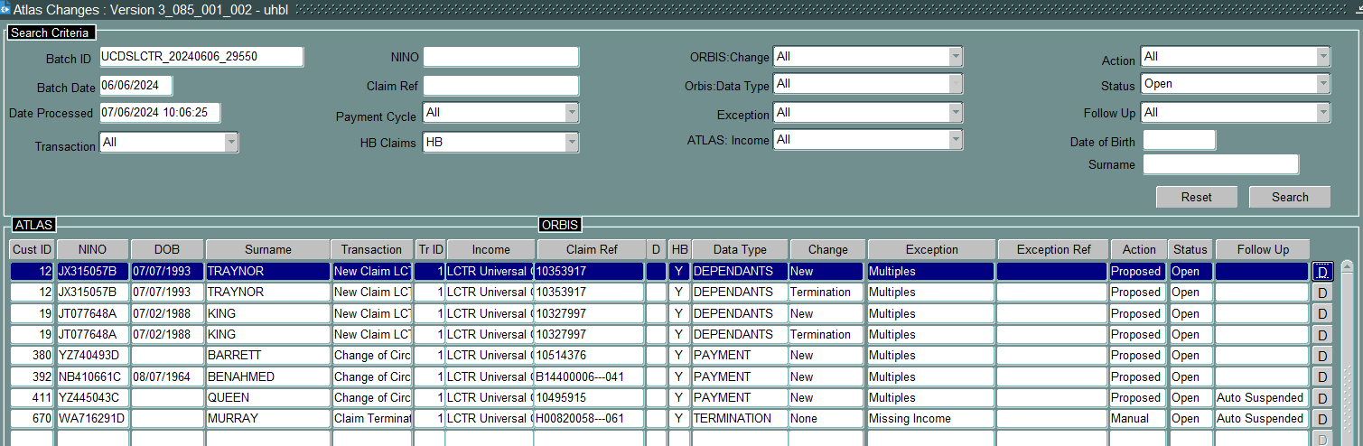

3.3 Before updating any UCDS, search using the claimant’s NINO so all outstanding UCDS/Atlas transactions are all updated at the one time even if one is UCDS and the other is Atlas. This allows all changes to be updated in the one day and stop numerous notifications and/or Council Tax bills being sent to the claimant causing confusion.

3.4 To search using the NINO, click on ‘review all batches’ and enter the NINO.

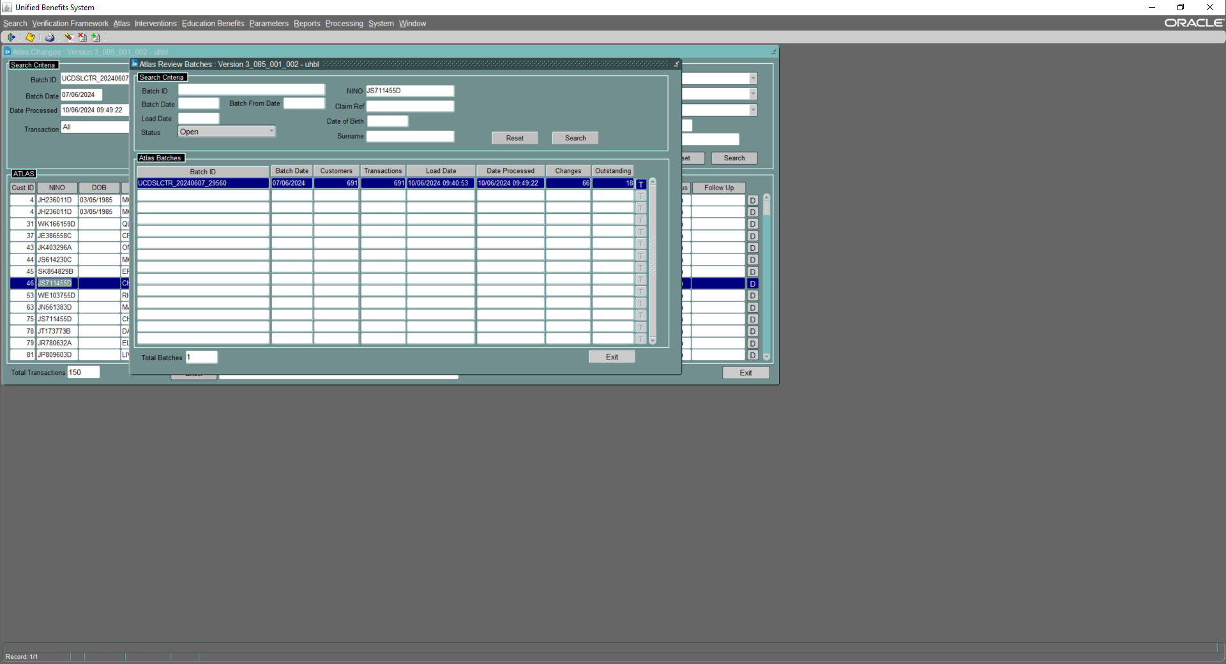

3.5 This will list all files that have outstanding transactions relating to that NI number and allow you to update each one in turn. When you have closed one transaction, you will need to ‘reprocess’ the next transaction to allow the details to show. This should happen for each transaction that follows until all transactions have been updated.

3.6 Multiple transactions within one file
If there is more than one transaction in a file, it will show the number of transactions within that file. This will occur when the DWP has reassessed a claimant’s UC award for a past period (see below). Click on ‘T’ to view the transactions.

3. Updating the UC details on the benefit claim (cont/d)

This will list all transactions and show if manual or proposed. You must open all the reports to identify any changes (and dates of these changes).

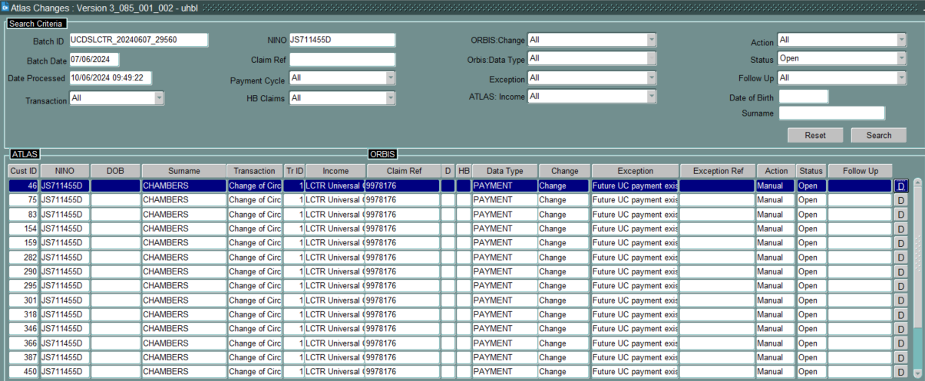

All transactions should be updated in one amendment (use a proposed change to do this if there is one) so only one change in circumstances is recorded for stats purposes.

After the claim is updated, the ‘manual’ transactions can be ‘closed’. There is no requirement to access the system to close each transaction individually. Click on the ‘Closed’ button at the side of the transaction.

3.8 Please see the following sections for details on how to deal with the following:

- See sections 4-7 for household changes
- See sections 8-14 for payment transactions

4. Household changes

4.1 UCDS can advise of a number of household changes:

- Partner added or removed from household composition (see section 5)
- Dependant children added or removed from household composition (see section 6)
- Dependant children becoming non-dependants (see section 6)
- Non-dependant moves in/out (see section 7)

4.2 When dealing with the UCDS changes, you should always check Civica (Benefits and Council Tax) to see if the claimant has reported a change in their household composition. If the claimant has reported a change and this differs from UC, we would update in accordance with the change the claimant has reported.

5. Claimant and partner changes

5.1 The UC transactions will detail any changes to the claimant and partner composition.

  - Claimant/partner moves out (see section 5.2)
  - Claimant/partner moves in (see section 5.3)
  - Claimant/partner dies (see section 5.4)
  - Partner is excluded from UC (see section 5.5)

5.2 Partner moves out of the household
For couples claiming UC, both are listed as ‘claimant’. If there is a change in household composition, you will generally receive a UC transaction for each claimant if both have updated their UC journals. These transactions show an exception ‘Change: UC Single Claim’.

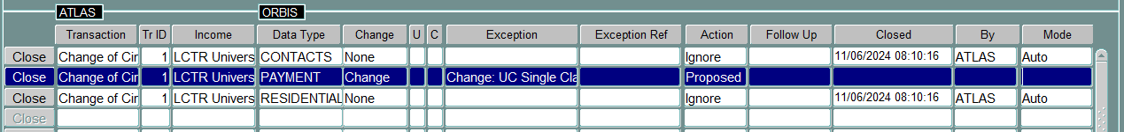

- The UC transaction can be used for the new CTR claim where one is required i.e. for the partner at their new address or if partner now becomes claimant at existing address
- The change takes effect from the new claim submission date (see below)
- The change for UC will take effect from the start of the assessment period that change occurs (start date). This will apply to both the claimant and the partner.

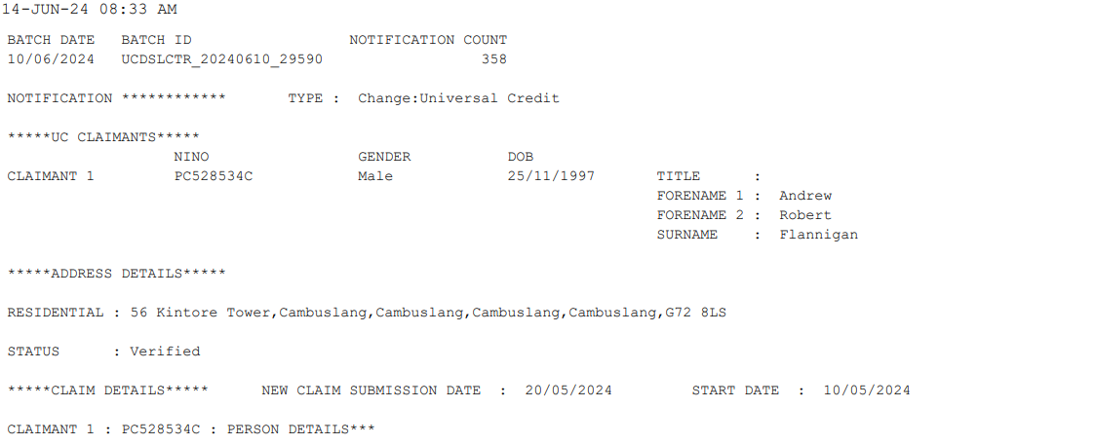
5. Claimant and partner changes (cont/d)

The claim should be updated from the ‘new claim submission’ date (along with the Council Tax liability). If the claimant reports a change at a later date and advises that the partner left at an earlier date, the dates can be amended.

- CTR claimant remains in property
  - If the CTR claimant remains in the property, end the partner from the day prior to the new claim submission date.
  - The partner’s claim should be loaded at the new address (if within SLC). The date of claim will be the new claim submission date and the start date the Monday following. The receipt date will be the date the UCDS transaction was received.
- CTR partner remains in property
  - If the CTR claimant has moved to another property within SLC, terminate the claim from the new claim submission claim date and copy the claim details to their new address.
  - If the CTR claimant has moved outwith SLC, terminate the existing claim from the Monday following the new claim submission date.
  - The partner’s new CTR claim should be loaded. The date of claim will be the new claim submission date and the start date the Monday following. The receipt date will be the date the UCDS transaction was received.

Couple separate and UC claim not updated
If we receive a change of circumstances notifying us of a claimant or partner leaving the property and their UC claim is still running as a couple, the CTR claim for each of the couple should be based on that person’s household composition but with the joint UC income until UC have updated their claim.

Each person must be advised to update their UC journal to report that they have separated.

NB: If the claimant or partner has moved to temporary accommodation and they have earnings included in the UC award, process the temp claim based on their earnings rather than the couple’s UC award as UC is a passported benefit for HB and the claimant is unlikely to qualify for maximum HB.

5.3 Partner moves into the household
If the claimant is single and a partner moves into the household, we will receive a UC transaction for the couple. There will be an exception on the transaction highlighting there is a change to claimant/partner details. These exceptions include:

- Partial UC claimant match
- New UC claimant

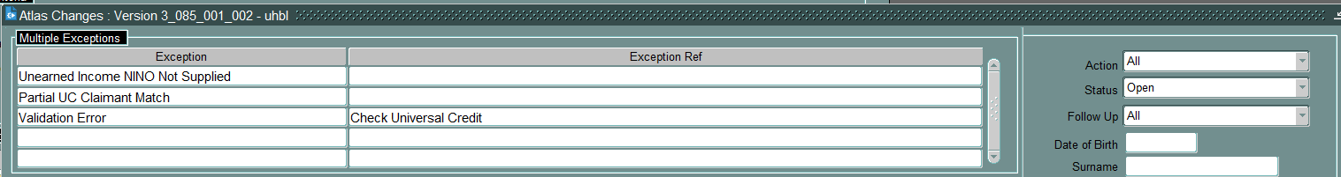

5. Claimant and partner changes (cont/d)

If a partner moves into the household part way through a UC assessment period, UC will assess the UC from the start of that UC assessment period. For CTR, the change takes effect from the ‘New Claim Submission Date’ detailed on the UC report.

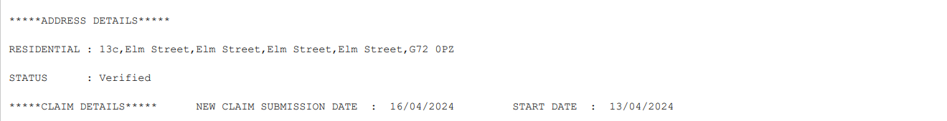

The claim should be updated from the ‘new claim submission’ date (along with the Council Tax liability). If it becomes known that the partner moved in at an earlier date, the dates can be amended.

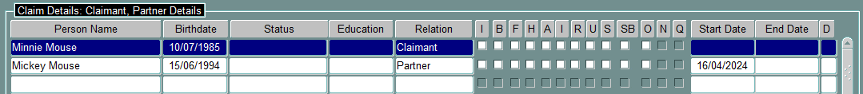

The UC assessment period in this example starts on 13/04/2024 as a joint UC claim. This should not be amended to start in line with when the partner moved into the household.

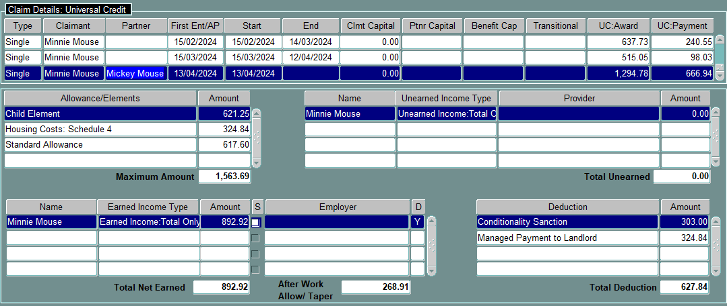

New Claimant/Partner due to name, NINO or DOB mismatch
Sometimes the system shows a ‘new’ claimant/partner because of a difference in that person’s details i.e. spelling of name. If there is no change to the claimant/partner details, edit the proposed changes to remove the termination and new details. If any of the person’s details are different on the benefit claim to the UC report, check what matches Searchlight as this is how the name should be loaded.

5.4 One of the couple dies
If there is a UC claim for a couple, and one of the couple dies, the UC award will continue for the assessment period in which the person dies and the following two assessment periods. This means the UC award continues as if that person has not died. This is called a ‘run-on after death’.

NB: If they were a mixed age couple and the person left is pension age, they remain a UC claimant until the end of the UC run on and cannot receive HB until the end of this period (if applicable). See UC terminations for CTR procedure for details.
5. Claimant and partner changes (cont/d)

For CTR, we are still required to end the person who has died the day prior to the date of death.

- If the person who died was the claimant for CTR, the CTR claim must be terminated from the Monday following the date of death.
- The new claim for the partner will start from the Monday following the date of death. The date of claim will be the partner’s date of death. The UC transaction for the partner can be used as the new application for CTR. If we have no UC transaction, write to the partner inviting them to apply for CTR. If HB is in payment (temporary or specified accommodation), the partner is required to complete a HB application before this can be awarded.

When we receive the UC award details, the person who has died will still show on the UC award and if the system ‘proposes’ the changes, the system will want to add the ‘deceased person’ onto the claim because they are included in the UC award.

- If the system proposes to add the deceased partner back onto an existing claim, ensure the new partner details are removed and the correct deceased end date still applies.
- If the system proposes to add the deceased partner onto a new claim, ensure the deceased partner details are removed from the claim (see example below).

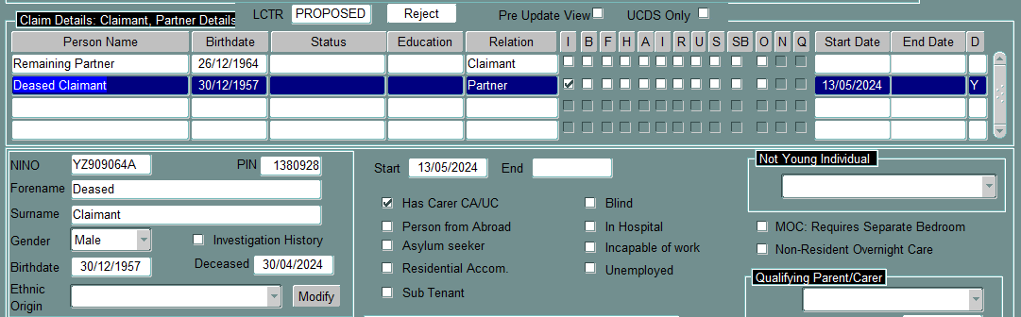

‘Reject’ then ‘Edit Proposed Changes’ to allow you to remove the partner from the claim.

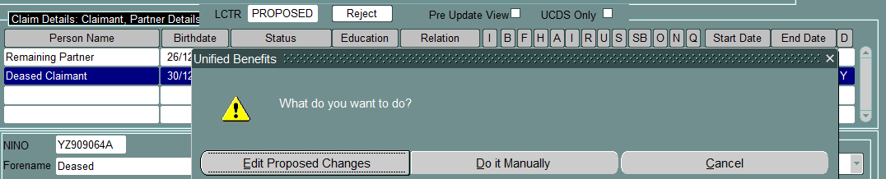

The system will ask if you want to edit the changes for other affected screens i.e. the UC award details on the ‘Universal Credit’ screen.

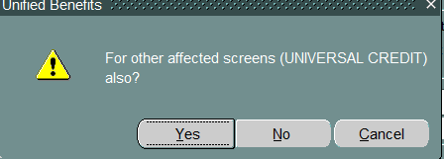
Answer ‘Yes’ to this as you will need to remove the partner from the UC screen as well.

5. Claimant and partner changes (cont/d)

Remove the proposed partner details from the claim to leave the partner as the sole claimant (new claim) or with the partner ended at date of death (existing claim).

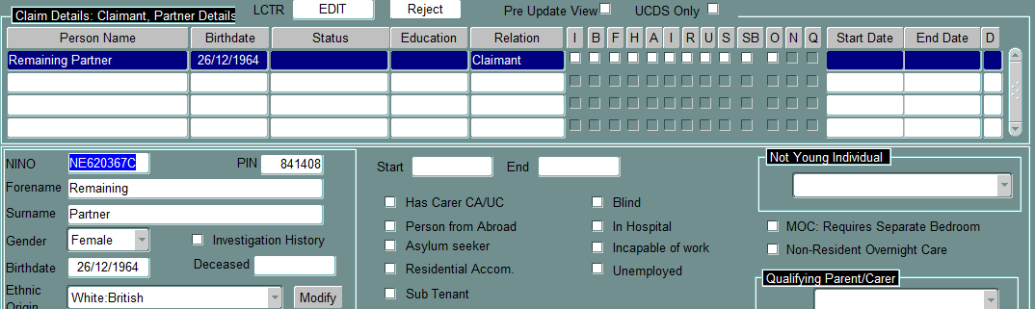

The Universal Credit screen will show the joint UC award details as the partner will continue to be included on the UC award until the end of the ‘run-on after death’.

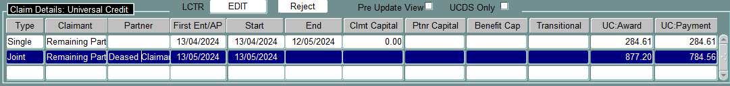

Amend the ‘Type’ to single and delete the partner details to allow you to progress with the claim.

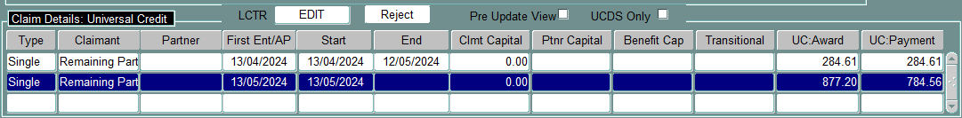

When the run-on after death has ended, you will start to receive the UC details for the remaining partner as a single claim.

5.5 Partner has no recourse to public funds
There will be occasions where you have a CTR claim for a couple, but the UC award is for a single person because the partner has no recourse to public funds (see below).

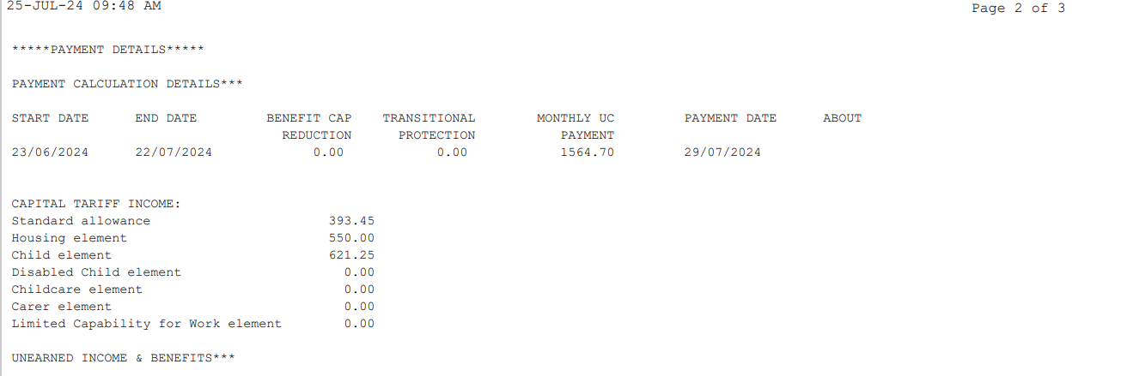

5. Claimant and partner changes (cont/d)

The partner may not have a NINO as they have no permission to work but they should be loaded on the CTR claim without the NINO. If the partner has permission to work, they may have a NINO if they have applied for this to undertake employment.

As the partner has no recourse to public funds, they are not eligible for UC and as a result, the UC award will be assessed as a single person (claimant) but if the partner has any income i.e. they are working, this income will be taken into account for UC and CTR.

As the partner is not detailed on the UC report, the system may propose to end the partner.
If this is the case, the changes should be rejected as the partner must remain on the claim.

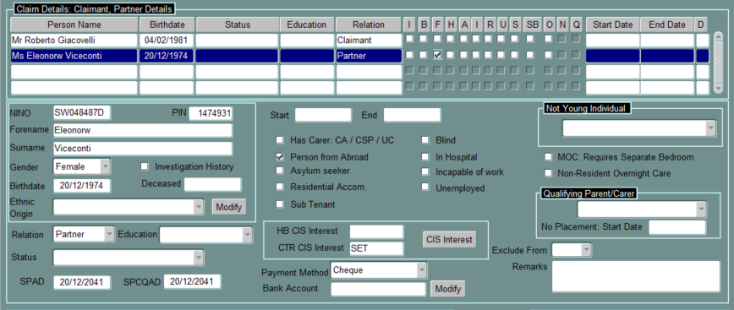

Important
If the claim is for HB, the partner must have a NINO for the claimant and partner to be eligible to claim HB. The eDCI1 must be sent to DWP for the partner to apply for a NINO.

- If the partner is allocated a NINO, the HB claim can be awarded.
- If the partner is refused a NINO for any reason other than ‘immigration status invalid’, the couple are not eligible for HB. CTR can still be paid.

6. Dependant children

6.1 Any dependant children included in the UC award must be loaded on the benefit claim. The UC report should detail all children in the household even if the claimant does not receive the child element for all the children due to the two-child restriction. This ensures the claimant receives the correct premiums in their CTR calculation and that the claimant receives any other additional help i.e. school clothing grants, free school meals etc.

6.2 From April 2026, DWP policy has changed and the two-child restriction has been removed. This means the claimant will receive a child element for every dependant child/qualifying young person.

6.3 If there are any changes to the household composition, or the child becomes a non-dependant, check Civica to see if the claimant has reported the change (as the date provided may differ from the date UC provides).

6. Dependant children (cont/d)

6.4 Please see the following sections for changes involving dependants:

- New dependant child – section 6.5
- Kinship children – section 6.6
- Dependant children on another claim – section 6.7
- Dependant child leaves the household – section 6.8
- Dependant child leaves the household – section 6.9
- Dependant child becomes a non-dependant – section 6.10
- Dependant child removed from claim – section 6.11

6.5 New Dependant Child
If we receive a UC transaction that shows a ‘new’ dependant, check the dependant screen for the child’s details. If the child has moved in (or was reported as being in the household) part way through a UC assessment period, UC will award the child element (where relevant) from the start of that UC assessment period. The date the change occurred is the ‘effective date’.

For HBCTR purposes, if the child has not previously been included on the CTR claim before, they must be loaded from the ‘effective date’ (unless the claimant has reported a different date) which can be found on the UC report.

NB: If the child is already on another benefit claim, see section 6.7 for details.

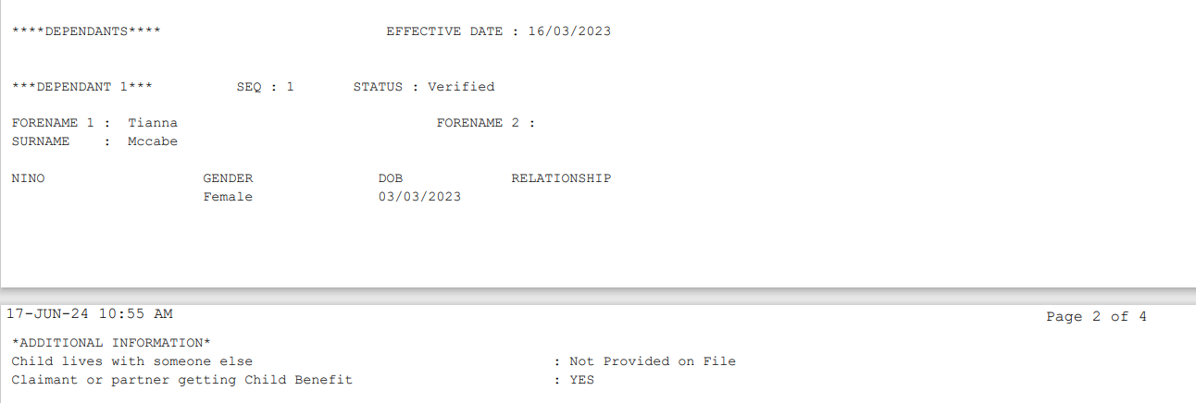

If the claimant is receiving the ‘disabled child’ element in their UC award, this means that one or more of the children are in receipt of DLA or Child Disability Payment (CDP).
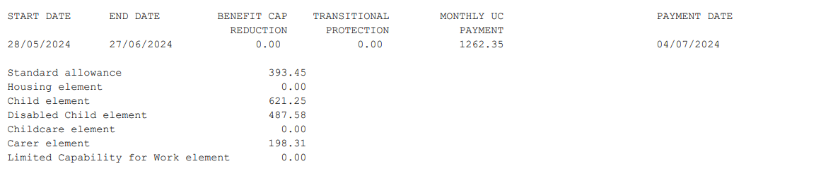

6. Dependant children (cont/d)

Check Searchlight in the first instance for all the children to see if CDP is in payment. Check the Data Sharing Portal for details of CDP. Load the disability benefit for the relevant child.

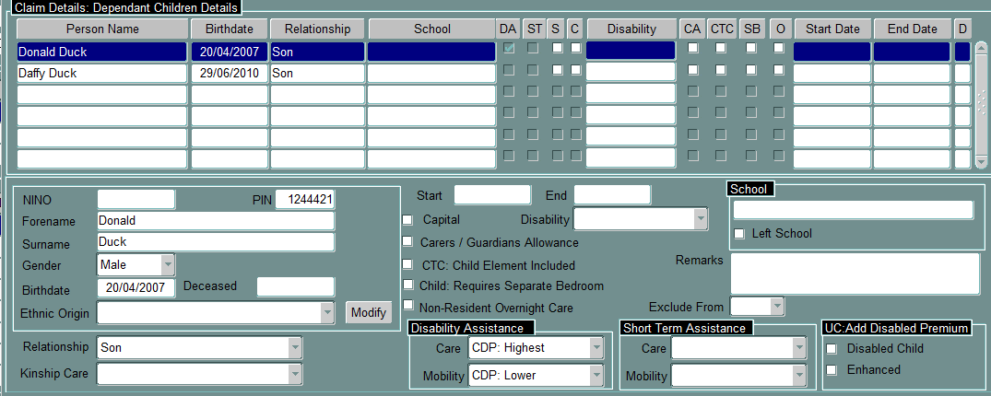

CDP Terminates
If the CDP award is terminated, the claimant will lose the Disabled Child Element in their UC award.

This means, if the claimant was receiving the Disabled Child Element and now they are not, you need to check Data Sharing Portal for the date CDP ended to allow you to update the dependant child details. You must also check to see if the claimant has requested a reconsideration of this decision and if so, have they been awarded CDP: Short-term Assistance. This does not give them entitlement to the Disabled Child Element in their UC award but the claimant is entitled to the relevant disabled child premiums in the CTR calculation.

The CDP: Short Term Assistance information must be recorded on the dependant screen and the relevant disabled child premiums applied manually.

Before – CDP in payment
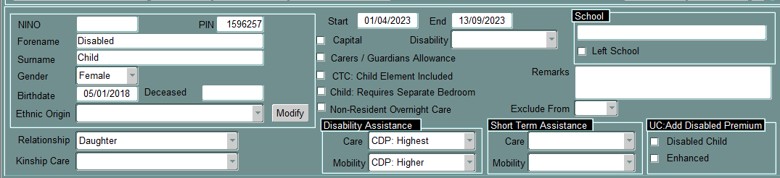

After – CDP Short Term Assistance in payment
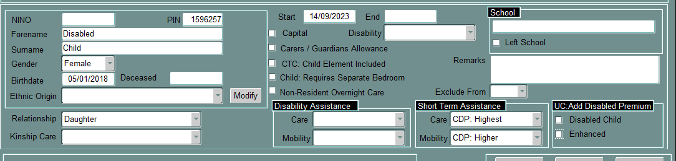

6. Dependant children (cont/d)

Awarding Disabled Child Premium and Enhanced Disability Premium for the child
To award the DCP and EDP for the child, you need to tick the ‘UC: Add Disabled Premium’ boxes.

- Disabled Child – gives the DCP and should be ticked if any rate of CDP is in payment (care and/or mobility)
- Enhanced – gives the EDP for the child and should only be ticked if high rate care is in payment

NB: If the claimant is entitled to both, both boxes must be ticked.

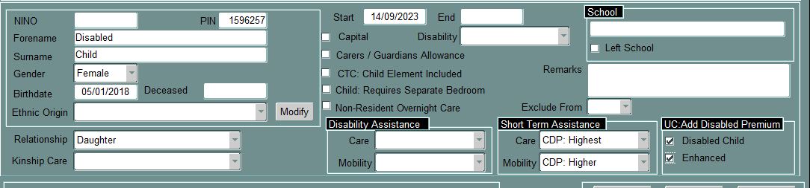

Amendment to the child’s details
Sometimes the system shows a ‘new’ dependant even though the child is already on the system. These usually detail a dependant ‘termination’ too as the system ends the existing child details and adds the new details from the start of the assessment period.

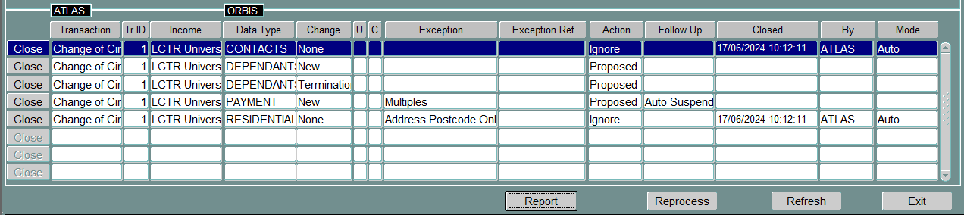

If there is no change to the dependant details, edit the proposed changes to remove the termination and new details. If the spelling of the child’s name is different on the benefit claim to the UC report, amend the dependant child details so they match the report. This will stop future termination/new transactions for that child.

NB: If there is an update for an existing child on the system, the new transaction removes any CDP flagged for the child. It is important that this is checked to ensure it is still in payment and if so, the details continue to be held against the child.

Child details before editing:

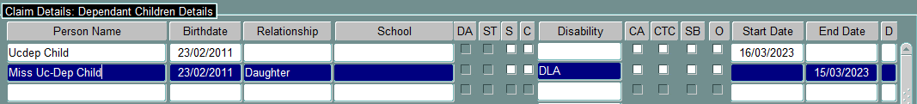

Child details after editing:

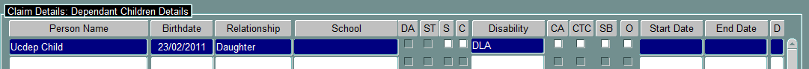

6. Dependant children (cont/d)

6.6 Kinship children
If the claimant is a kinship carer and they have been awarded the child element for the child they are caring for, they must be included as part of the household for CTR.

If there is no child element but the child is listed on the UC report as a dependant child, UC have accepted that the child is part of the household and should be included on the dependant screen.

If HB is in payment, any new child where there is no child element and/or claimant has indicated they are not receiving Child Benefit for the child, you must verify whether the child is looked after by the local authority or not before deciding if they are part of the household for HB (see the foster and kinship carer procedure for further information). If the child is looked after, they are not included as part of the household for HB and the child should be excluded as shown in section 6.7. As the child is part of the household for CTR, flag the child as ‘exclude from HB’ is flagged while waiting on the information.

6.7 Dependant child is on another benefit claim
If there is a dependant child on a UC claim and they are on another claim, check to see if UC have awarded the child element for that child.

- If they have been awarded the child element, the child must be loaded on that CTR claim as we must go in line with the UC decision as they have decided the claimant is the main carer. This applies to CTR only and if the child is not part of that household as they are being cared for elsewhere, they must be excluded for HB.
- If the child element has not been awarded, the child should not be included at this time as UC have decided that the claimant is the lead carer for that child. If they revise this decision at a later date, then the CTR claim can also be revised and the child added as a dependant.

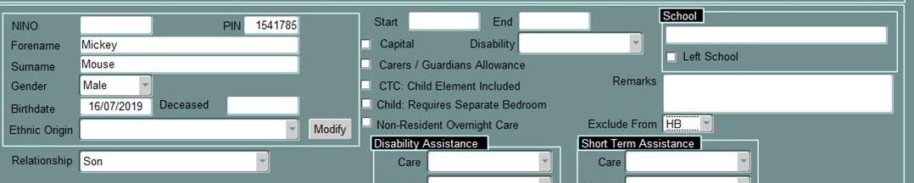

There may have been a recent change to the child’s care arrangements, and these are not yet reflected on the other claim. Check the other claim to see if there have been any recent changes reported i.e. claimant reported that child has now moved out. If there are no changes reported, check to see if that claimant receives UC.

If UC is in payment, check to see if the claimant still receives the child element for that child. If the child element is no longer included, ensure the child is ended on that claim. If there are no changes to the child element, we need to leave the child on the claim.

If there is no UC in payment, write to the claimant to ask if there are any changes to the care for the child. If the claimant advises they are still the main carer for that child and nothing has changed, we need to leave the child on that claim. This can result in the child being on more than one claim.

6. Dependant children (cont/d)

6.8 Child element ends for a dependant child
From April 2026, the two-child restriction for UC has been removed. This means the claimant will receive a child element for every dependant child in the household for whom they are the main carer.

If the claimant no longer receives the child element for a child, this means the child has either left the household or they are now a non-dependant.

- Check the UC report to see if the dependant is listed as a non-dependant before deciding if the child is part of the household and
- Check Civica to see if the claimant has reported a change regarding the dependant child.

If the child has left the household, see section 6.9 and if the child is now a non-dependant, see section 6.10.

NB: For dependant changes prior to April 2026, please refer to the TL update – June 2025 for how to deal with these.

6.9 Dependant child leaves household
If the dependant child has left the household, end the child from the date left. The UC report will not detail this so you will need to check Civica to see if the claimant has reported the change.

If you do not know the date the child left the household, end the child on the day prior to the start of the UC assessment period the child is no longer included and write to the claimant to ask for the date the child left. If the claimant responds, we can amend the end date for the child.

NB: There is no requirement to suspend the CTR claim waiting on date the child left as they will already be ended on the claim.

6.10 Dependant child becomes a non-dependant
If the child has become a non-dependant, the UC transaction will show dependant termination and a new non-dependant within the UC transaction.

The dependant child should be ended on the day prior to the ‘effective date’ and started as a non-dependant from the effective date unless they have left school or non-advanced education or training, then they should be ended from the date entitlement to child benefit ends:

- 28 February
- 31 May
- 31 August
- 30 November

6. Dependant children (cont/d)

UC will end the child element for that child from the date the change occurred rather than the assessment period the claimant stops receiving child benefit for them. If this occurs, the child should be added as a non-dependant from the date child benefit entitlement ends (as above).

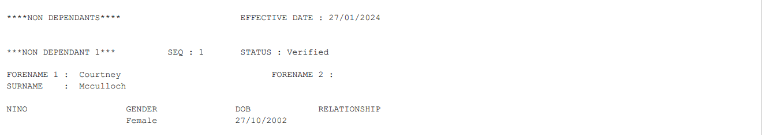

If the claimant and/or partner is in receipt of ADP, SADLA or PADP (care element), the non-dependant income should be flagged as ‘unknown’.

NB: If the non-dependant is in receipt of CDP or ADP (care element), this must be flagged for the non-dependant to ensure the claimant/partner’s applicable amount is calculated correctly.

If the claimant and/or partner are not in receipt of ADP, SADLA or PADP (care element), check Searchlight to see if the non-dependant is in receipt of UC or any state benefits.

- If the non-dependant is in receipt of UC, follow the Non Dependants and Universal Credit desk aid on how to load this income (and check if earnings are included in UC).
- If the non-dependant is in receipt of a state benefit e.g. new style ESA, load the amount of the state benefit as income and the hours are zero.
- If the non-dependant is in receipt of CDP or ADP (care element), this must be flagged on the non-dependant screen for that person to ensure the claimant/partner’s applicable amount is calculated correctly.

If the non-dependant is not in receipt of UC or any state benefits, load the non-dependant income as ‘unknown’ and write to the claimant to request income and evidence.

There is no requirement to pend the work item on Civica. The non-dependant income will be left as unknown income unless the claimant responds.

- If the claimant provides the details and evidence requested within one month from the date requested, the non-dependant income should be revised from the date the income was ticked as unknown.
- If the claimant provides the details and evidence requested outwith one month from the date requested, the non-dependant income should be amended from the date notified.

NB: If the claimant is living in temporary or specified accommodation and HB is in payment, the ‘income screen’ on Searchlight can be used to verify earnings a non-dependant has.

6. Dependant children (cont/d)

6.11 Dependant removed from a claim
There are occasions where the system may remove a dependant child from the claim and shows a ‘dep termination’ within the UC transaction. This can happen if there has been a dependant on the claim who has been ended i.e. became a non-dependant or left the household at an earlier date to the UC claim.

If the number of dependants on the UC report match those on the benefit claim but the UC transaction shows there was a dependant termination proposed, click on the ‘pre-update’ view that will show you what was displayed on the dependant screen before the UC transaction was received.

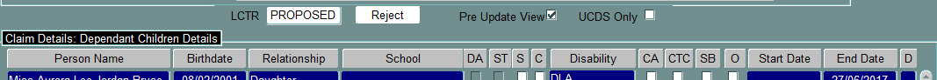

If the system has removed a dependant in error, edit the changes and add the dependant back on, the way it was prior to UC.

NB: Ensure if there are any other changes to the dependant screen, these mirror UC.

7. Non-dependant moves in or out of household

7.1 If a non-dependant moves in or out of the household, for UC, this will take effect from the start of the assessment period in which the non-dependant moves in or leaves. For HBCTR purposes the date of change is the date moved in or out or, if the change is beneficial, the date the change was reported i.e. date UC transaction received.

NB: Check Civica (Benefits and Council Tax) to see if the claimant has reported the change. If they confirm a different date to UC, we use the date the claimant reported. If the change is beneficial, we use the earliest date reported (claimant and UC) to update the change.

7.2 Non-dependant moves in
If there is a non-dependant on the UC transaction and they have not previously been on the benefit claim, they should be added to the claim from the ‘effective date’ (see below) or the date the claimant reported (if applicable).

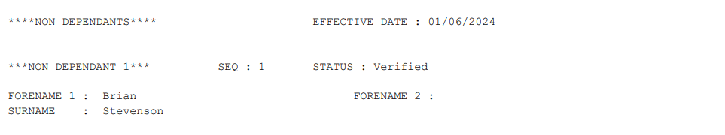

7. Non-dependant moves in or out of household (cont/d)

If there is no effective date and the claimant has not reported the change, the non-dependant should be added from the start of that assessment period.

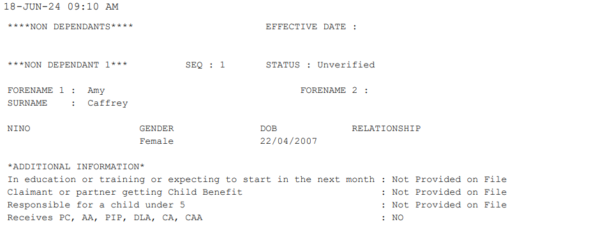

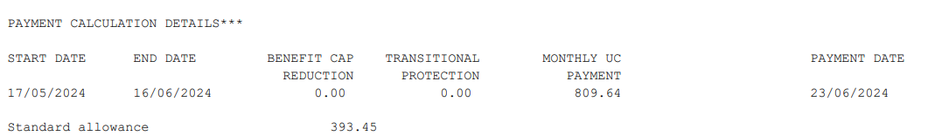

The UC report will not detail the income the non-dependant receives. See section 6.10 for details on how to verify the non-dependant income and what to load on the system.

7.3 Non-dependant not on UC report
If there is a non-dependant on the benefit claim but not on the current UC report, this means they are no longer part of the household.

If there is more than one non-dependant in the household and one of the non-dependants is no longer part of that household, there may be an ‘effective date’ for the remaining non-dependants on the UC report. This is treated as the date the relevant non-dependant left.

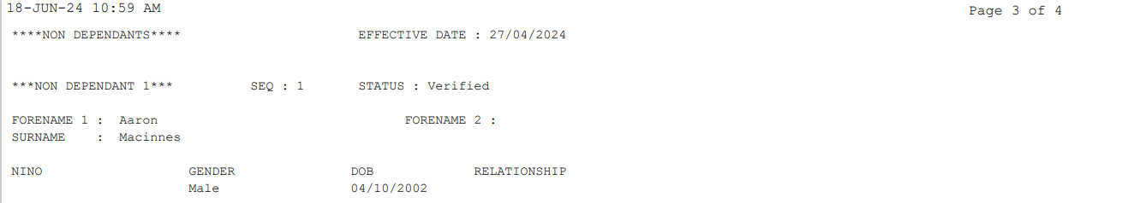

If there is no longer a non-dependant in the household, there will be no non-dependant details on the UC report.

Before ending the non-dependant, check Civica to see if the claimant has reported the change. This should include Council Tax as the claimant may have applied for single persons discount because of the non-dependant leaving.

7. Non-dependant moves in or out of household (cont/d)

If the claimant reports the change and confirms the date the non-dependant left, this would be used even if there is a ‘effective date’ on the UC report.

- If you know the date the non-dependant left i.e. claimant reported the change or there is an ‘effective date’ on the UC report, and this has been reported within one month, end the non-dependant from the date left.
- If you know the date the non-dependant left i.e. claimant reported the change or there is an ‘effective date’ on the UC report, and this has been reported outwith one month, end the non-dependant from the date the change has been reported (claimant or UC transaction, whichever is earliest).
- If you do not know the date the non-dependant left i.e. claimant has not reported the change and there is no effective date on the UC report, end the non-dependant from the day prior to the start of the current UC assessment period.

8. UC Payment Transactions

8.1 When a UC payment transaction is received, the report will give a breakdown of the UC award and if there is any earned and unearned income included.

8.2 Please see the following for further details on how the income should be loaded on the claim and the effect this has on CTR:

  - For earned income and childcare costs, see section 9
  - For UC – Self Employed earners, see section 10
  - For unearned income, see section 11
  - For capital, see section 12
  - For transitional protection, see section 13
  - For changes to allowances/elements, see section 14
  - For UC and Benefit Cap, see section 15
  - For a change of address, see section 16

9. Earned Income and childcare costs

9.1 Any earned income included in the UC award is held on the Universal Credit screen. There is no requirement to load this information on the earned income screen. CTR is calculated using the net earnings (prior to any taper/work allowance deductions).

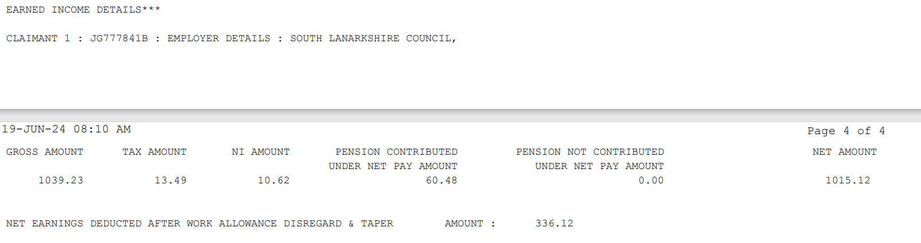

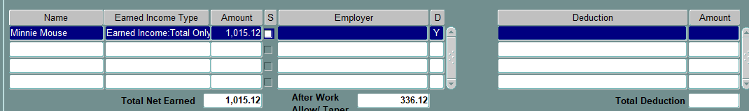
9. Earned Income and childcare costs (cont/d)

9.2 If the claimant has childcare costs, the UC report will detail the childcare costs and who the childcare provider is and there will be a ‘childcare element’ included in the claimant’s UC allowances/elements.

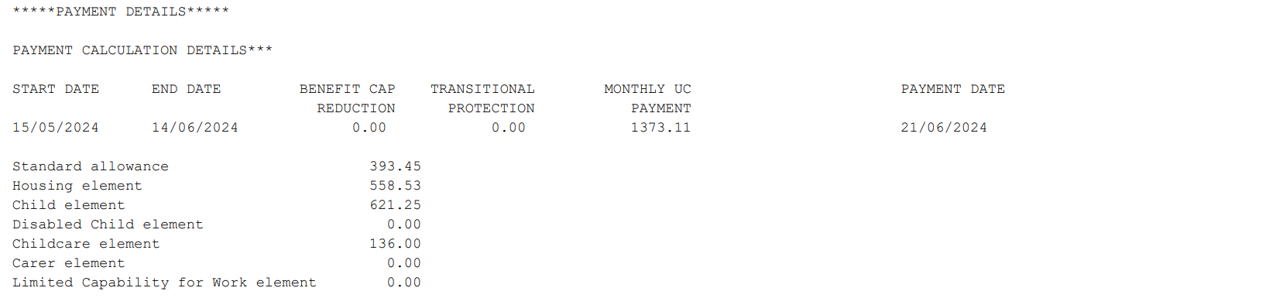

9.3 The system will calculate CTR entitlement based on these costs and the children that are on the claim.

9.4 If the claimant has previously been in receipt of CTR and has been awarded UC, please ensure any existing earned income is ended on the day prior to the start of the UC award (UC assessment period start date).

10. Self Employed earners

10.1 If a claimant is self-employed a breakdown of the self-employed income will be detailed on the UC report. This will include the following:

  - Indicator showing they are self-employed
  - Gross and Net income from self-employment (also lists expenses declared)
  - Minimum Income Floor start date
  - Minimum Income Floor income

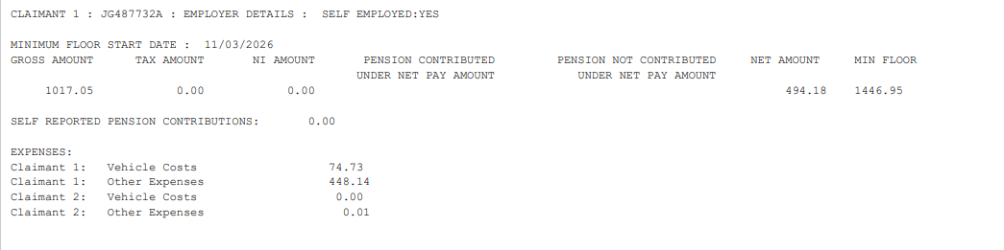

10.2 If the system has proposed the UC changes, the ‘S’ indicator will be ticked and it will propose the ‘net earnings’.

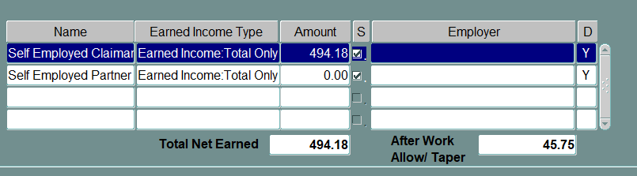

10. Self Employed earners (cont/d)

10.3 You must check the report to see if the Minimum Income Floor (MIF) amount should be used in the assessment for CTR.

- If the MIF start date is in the future, then the net earnings are taken into account.
- If the MIF date is before the start of that UC assessment period, the MIF figure must be used. You need to edit the proposed changes and amend the net earnings figure. The after work taper will remain unchanged.

10.4 If you are unsure whether to use the MIF figure due to the net earnings and after work taper figures provided, check Searchlight BETA to verify the take home pay and the net earnings figure used in the UC calculation (the verifying UC for CTR procedure provides full details.

11. Unearned Income

11.1 If the claimant receives any other income that is not earnings, this will fall under ‘unearned income’.

11.2 The UC report does provide details of any state benefits in payment i.e. Carer Support Payment. We also receive Atlas transactions for any state benefits in payment.

11.3 You need to cross check the unearned income included in the UC with the unearned income loaded on the unearned income screen. If there are any differences, you must ensure:

11.4 All state benefits in payment are loaded on the unearned income screen.
Any state benefits no longer included in the UC screen are ended (where relevant) on the unearned income screen.

11.5 If the unearned income screen has any other income loaded e.g. student income, works pensions etc., these must be removed from the unearned income screen from the date they were loaded as we are unable to verify these.

11.6 State Benefit amounts included in UC do not match full award
If the claimant is awarded a new state benefit e.g. new style ESA or the state benefit has come to an end, the amount included in the UC award may not match the full award amount that is on the unearned income screen.

This is because UC only include the number of days in that UC assessment period that they received that income for. In these cases:

- For new awards, the full weekly amount should be loaded on the unearned income screen with a start date as the date awarded.
- For end of awards, the state benefit should be ended from the date the award ended.

NB: All state benefits should be loaded on the unearned income screen as a weekly amount in line with Atlas changes.

12. Assumed Yield Capital

12.1 If the claimant has a capital tariff included in their UC award and the changes are proposed, this will show under unearned income.

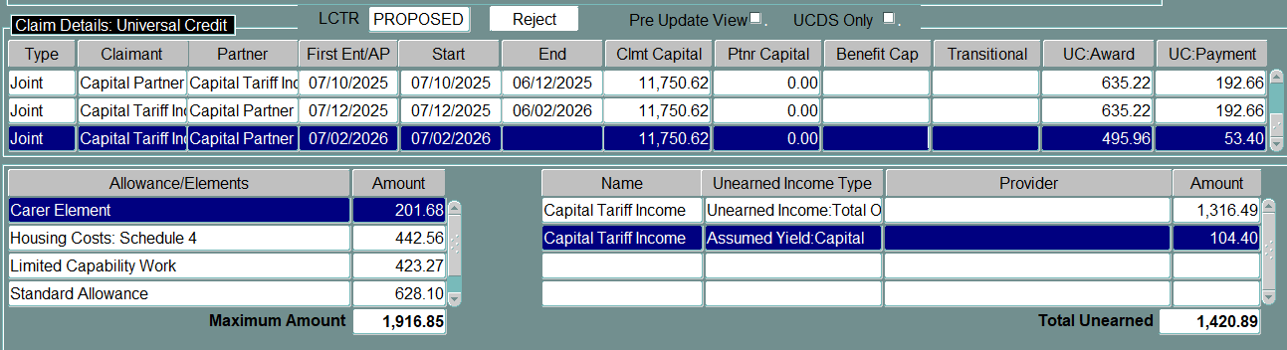

12.2 If the changes are manual, the amount of tariff income included in the UC will be detailed in the UC report and must be loaded under unearned income on the UC screen. The capital amount should also be loaded. This is not detailed on the report.

- If there was tariff income included previously and this has not changed, the amount of capital the claimant has should be on the Universal Credit screen.
- If this is the first time tariff income has been included, use the capital tariff for Universal Credit desk aid for the capital range for that tariff income. Load the capital amount as a figure within this range.

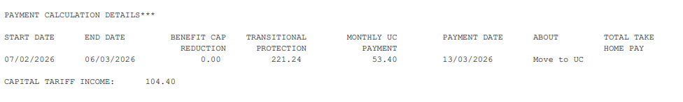

13. Transitional Protection (Transitional Element)

13.1 When a claimant moves to UC from a legacy benefit, they will be awarded a transitional element within their UC if they are worse off under UC.

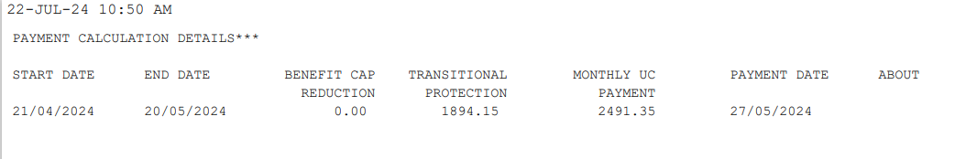

Any ‘Transitional Protection’ amount must be included in the ‘Allowances/Elements’. If the changes have been proposed, the amount will automatically be included in the allowances/elements as ‘Transitional Protection’. If the changes are manual, this must be manually added to the allowances/elements.

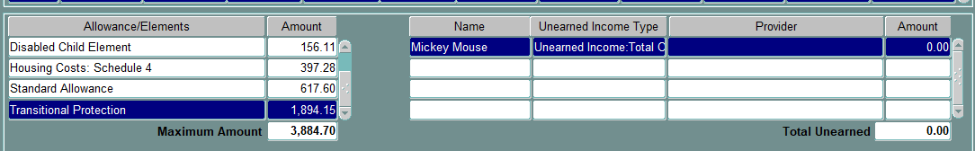

14. Changes to allowances/elements

14.1 If there are any changes to the allowances/elements, you must check to see if this has any other impact on the claim. Most changes to allowances/elements will have an exception on the UC transaction but not always.

14.2 The main elements that require further checks if are new, changed or removed are:

- Child Element
If there is a change to the child element, this means there is a change to the number of dependant children included in the UC award. Check the UC report for the children and compare these to the dependants on the system. If there are any changes, see section 6 for details.

- Carer Element
If the claimant has been awarded the carer element, this means they are looking after someone or they satisfy the qualifying conditions for being a carer (carer credits). You are required to check who they are caring for if the claimant/partner receives Carer Support Payment. The UC new claims for HBCTR procedure provides full details of the checks required.

- Disabled Child Element
If the claimant has been awarded the Disabled Child Element, or this amount changes, this means the claimant has one or more disabled children in the household. Check the dependant child screen to see if any of the children have been flagged as disabled and if this matches the Disabled Child Element. If not, you are required to check which children are disabled. See section 6 for details.

15. UC award and Benefit Cap

15.1 If the claimant is subject to Benefit Cap and this has been applied to their UC claim, the amount will be included on the UC report. If the claimant had been receiving UC before the benefit cap applied, you must check Civica to see if there is a DHP application pending.

15.2 If there is a DHP application pending, reactivate the process so the processor can award the DHP in line with the UC award.

15.3 To reactivate the work item, right click on the process and ‘open process’ (you do not need to pick this up).
- Click on ‘Options’ and ‘Update’.
- Click on ‘Change Stage Type’ which will currently show as ‘Waiting’.
- Amend the ‘stage type’ from Waiting to Action.
- This will reactivate the process back to the person who pended the claim originally.

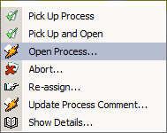

15. UC award and Benefit Cap (cont/d)

Before
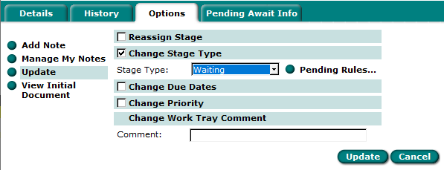

After
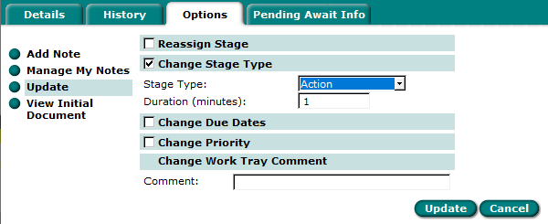

16. UC report shows a change of address

16.1 If there is a change to residential information on a UC claim, the system will ignore this as the majority of the time, it is to do with the format of the address.

16.2 There are occasions though that a change of address that has been ignored can be attached to UC payment details and there will be an exception ‘address mismatch’. This will occur when the change of address happens during the current UC assessment period.

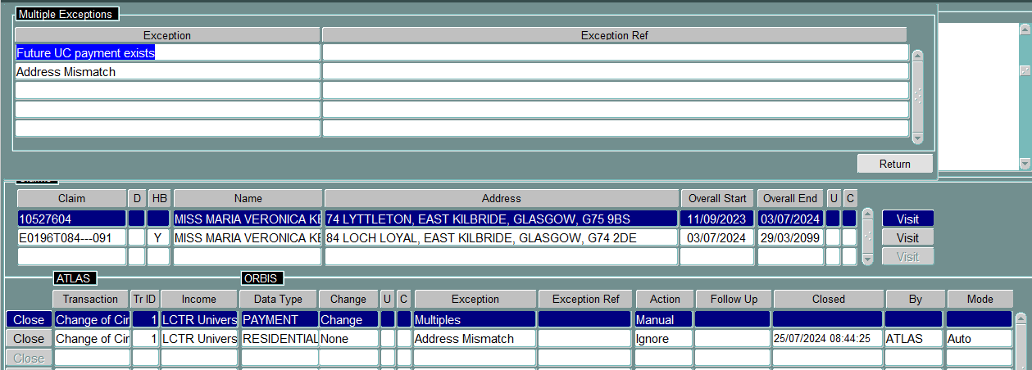

16. UC report shows a change of address (cont/d)

16.3 As UC is paid in arrears, if the claimant has reported the change of address to us, this may already be actioned (as above). If the address on the UC report differs from the current address on the benefits system, the following should apply.

- If it is a public sector claim, check the HOME system to see if the claimant is a tenant at the new address.
- Check Council Tax to see if registered as liable at the new address.
- Check Civica (Council Tax and Benefits) to see if the claimant has reported the change but this has not yet been actioned.
- Check the UC report for the effective date (date UC notified of change of address) and any landlord details or if housing costs awarded (indicates if claimant has a rental liability).

16.4 CTR only
If the claimant has reported the change of address, follow the normal change of address rules, and copy the claim details (if the change of address is within SLC) from the date moved.

If the change of address has not been reported and the claimant is:
- a liable person at the new address - copy the CTR claim from the effective date on the UC report.
- a non-liable person or liability not known - terminate from Monday following the effective date as we know they are no longer at the address. Send the BEN Entitlement letter/email to invite the claimant to apply for CTR at the new address. If the claimant completes the online application, copy the claim following normal change of address rules.

16.5 Change of address from temporary to mainstream accommodation
If a claimant is living in temporary accommodation and are given a mainstream tenancy (with any landlord), they can continue to receive HB at their temporary accommodation until they report to UC that they have moved address.

The UC report will provide a ‘move in’ date and this is the date that should be used. This will be the date UC use to assess what UC assessment period to pay the UC housing costs from.

If the ‘move in’ date is before the start of the tenancy, the claim must be copied from the date the keys were returned. The claim cannot start earlier than the tenancy start date.

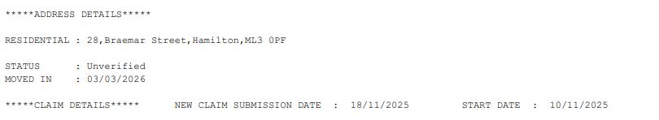

17. Claimant does not qualify for CTR based on UC income

17.1 If the claimant has a UC award but does not qualify for CTR based on their income i.e. net earnings are used to calculate CTR but amount after work allowance/taper is used to assess UC, the claim should be left running as a non-qualifier for three months before terminating the CTR. This allows us to assess if there are changes in earnings that fluctuate (may qualify for CTR on and off so the claim would be left running).

17.2 If the claimant has not qualified for CTR for three full months (or longer if UC changes have been auto-updated), terminate the CTR from the Monday following the end date of the latest assessment period. This will stop any further UC transactions being received that are not required. You must wait for the three months before terminating the claim.
Example
UCDS transaction received on 28/07/2024 for the UC assessment period 28/06/2024 to 27/07/2024. Details are updated on the Universal Credit screen.

The calculation screen on the benefits system shows the claimant last qualified for CTR on 31/03/2024. This means the claimant has not qualified for CTR from 01/04/2024 to 28/07/2024 (three full UC assessment periods).

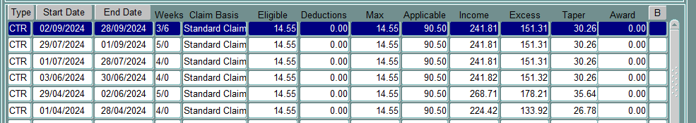

The CTR claim should be terminated from 29/07/2024 (Monday following 28/07/2024).

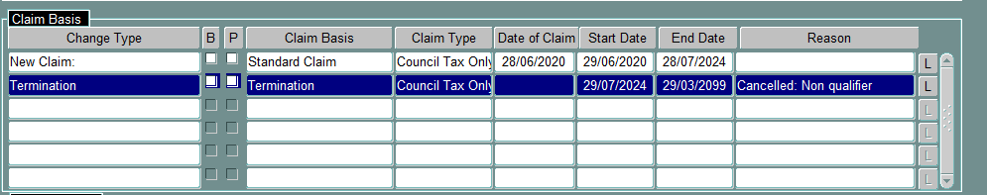

18. UC non-qualifiers and Housing Benefit

18.1 If a claimant is in receipt of HB and UC, UC is a passported benefit meaning they will be eligible for maximum HB (less any non-dependant deductions). If the claimant has a UC nil award, they are not entitled to maximum HB as they are not in receipt of UC.

18.2 The UC nil awards for Housing Benefit procedure details the process on how to process these claims.

19. Further information

19.1 Further guidance on processing UC can be found in the following procedures:

  - Housing Benefit Stop Notices (Housing Benefit folder)
  - New claims for Universal Credit claimants (Council Tax Reduction folder)
  - UC nil awards for Housing Benefit (Housing Benefit folder)
  - UC terminations for CTR (Council Tax Reduction folder)

19.2 The following desk aids are available as a quick referral guide:

  - Capital Tariff for Universal Credit (Council Tax Reduction folder)
  - Non Dependants and Universal Credit (Council Tax Reduction folder)
  - UC Allowances and Elements
  - Verifying Universal Credit using Searchlight (Housing Benefit and Council Tax Reduction folders)

19.3 If you have any questions about the contents of this procedure, please contact Policy.

Record of Amendments

Date | Amendment Made | Reason for amendment | TL Update included in (if applicable) | Version Number
August 2024 | Section 2.7 – added pre-update and UCDS to proposed transactions  Section 3.6 – multiple transactions – update all in one update and close the others  Section 4.2 – check Civica for any changes reported by claimant  Section 5.4 – one of couple dies – reworded to make clearer  Section 6.3 – kinship – if on as dep, include as dep on CTR claim even if no child element (as two already awarded)  Section 6.5 – added section to check if dep removed from claim  Section 6.6 – expanded section about verifying non-dep income and clarified process  Section 7.1 – added about checking Civica for a change reported by claimant  Section 8.4 – added a NB about using appropriate year’s work allowance  Section 8.5 – added paragraph about partial unearned income amounts (for state benefits)  Section 8.9 – added section about UC and Benefit cap  Section 11.4 – added section about temp accommodation and verification. Also contact policy for backdated terminations  Section 12.2 – HB eligibility – if couple and one dies and remaining partner pension age, not eligible until end of run-on  Appendix 2 added for creating an intervention. | Clarification following training | August 2024 | 24.02
August 2024 | Added paragraph to 8.5 regarding HB overpayments being included as UC unearned income for the claimant’s first assessment period and not to include as income for CTR | Query regarding HB overpayments and unearned income and clarification from DWP | August 2024 | 24.03
September 2024 | Added section 2.2 – information that is shared with LA in relation to UC | Move to UC guidance provided by DWP (v3) |  | 24.04
March 2026 | Reviewed full procedure.  Added removal of two child restriction effective April 2026 and the impact on verifying children on a CTR claim. Referral to TL update (June 2025) for process in place prior to April.  Removed any mention of DLA, PIP and existing legacy benefits in procedure. All disability benefits transferred to SSS and move to UC completes end of March 2026.  Self employed income – UC and Searchlight enhancements have taken place over the last year and incorporated all the changes into the procedure – including breakdown of SE income, MIF (and when this applies from).  Unearned income – reviewed process to only include State Benefits on unearned income and to remove any assumed income e.g. student income, works pensions etc. from the unearned income as unable to maintain these moving forward (increase in UC automation)  UC and Benefit Cap – removed need to refer to DHP if claimant affected by Benefit Cap and not in receipt of DHP – report available to highlight these cases. Also moved the section regarding reactivating the Civica work item to include within this section so that it sits in one place.  Assumed yield capital – amended to advise now shows on UC report as part of the DWP enhancements that have taken place.  Changes from temp to mainstream – move in date provided on report and should be used to end temp and transfer to mainstream tenancy.  Removed UC non qualifiers and Housing Benefit as now in separate procedure (UC nil awards and HB).  Removed UC termination section as now in separate procedure (UC terminations for CTR).  Removed capital tariff for UC from appendices as now desk aid  Removed creating an intervention as now in UC termination procedure | Completion of move to UC and removing legacy benefits that no longer exist  Removal of two child restrictions for UC  UC enhancements for UCDS and Searchlight to streamline processes |  | 26.01

