South Lanarkshire Council

Microsoft Surface Hub 2S



Quick Reference Guide

Topic A Microsoft Surface Hub 2S Overview 2
Topic B Interact with Surface Hub 3
Use the Whiteboard 4
Surface Hub with Microsoft Teams 5
Connect your laptop to Surface Hub 7
Sign-in to your Office 365 account 8
Start menu 9
End the Surface Hub session 10
Device Troubleshooting 12
Additional Resources 14

Topic A Microsoft Surface Hub 2S Overview

Microsoft Surface Hub 2S is a team collaboration device designed to advance the way people work together. Surface Hub enhances the mobile meeting experience by using an interactive, collaborative Whiteboard, Microsoft Teams, Office apps, and Email to share content and meeting notes.
Surface Hob Components
The Surface Hub 2S includes highly refined technology with a thin bezel, light weight, and Ultra High Definition display.

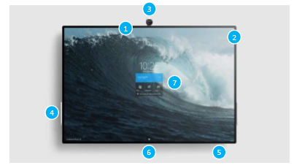
No. | Component | Description
1  2 | Microphone  Speakers | A high-quality microphone and stereo speakers let you converse naturally with remote participants
3 | Camera | Surface Hub includes a high definition camera for video calling and meetings
4 | Pen | Use the tip of the active pen to write, draw, capture, or select. Use the flat end as an eraser
5 | Surface buttons | Buttons for Power, Volume, and Source selection are in the bottom right underside of the bezel
6 | Ports | Located on the bottom of Surface Hub are the ports for USB-A, Mini DisplayPort output, HDMI input, USB-C with DisplayPort input, and RJ45 Ethernet
7 | Touchscreen | Use the touchscreen to open apps, write or draw on the whiteboard, join a meeting, and more
The Surface Hub has an onboard computer that supports Microsoft Teams meetings, Microsoft Edge and Office 365 apps like Word, Excel, and PowerPoint.

Topic B Interact with Surface Hub

You can interact with Surface Hub in several ways:
Touch
Surface Hub is designed for touch. Start a meeting, invite others to join you, open apps, write on the whiteboard, send the results of the meeting to yourself and others – you can do it all with touch. When you need to enter text, a touch keyboard is displayed.
Pen
The pen is designed to be lightweight and easy to use for writing ideas and collaborating with colleagues. If you make a mistake, just turn the pen around to erase.
Devices
You can use the Surface Hub as a display for your laptop, tablet, or smartphone.
Welcome screen
The Welcome screen is displayed when Surface Hub wakes up. You can wake up the device by walking up to it or tapping the screen with your finger.

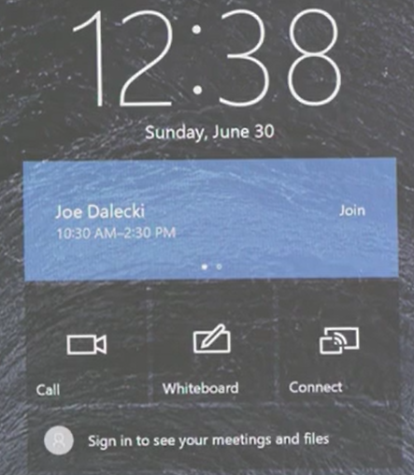

Surface Hub 2S Welcome screen
From the Welcome screen, you can start a scheduled or ad-hoc meeting, access the Whiteboard app, connect your device, or sign-in to your Office 365 account. You can also open the Start menu to select an app, such as Word or Excel and the Microsoft Edge browser.

Use the Whiteboard
The Whiteboard app lets people collaborate in a traditional brainstorming session and take notes on the meeting. It can be used at any time on the Surface Hub and is accessed from the Welcome screen by tapping on the Whiteboard tile.
The Whiteboard enhances the collaboration experience by providing fluid inking and versatile editing tools on an infinite canvas.
1
2
3
4
5
6
7
8
9
10

Whiteboard inking and editing tools

No. | Description
1 | A palette that provides a choice of ink colours
2 | Highlight content, like a physical highlighter pen
3 | Locks in the erasing function for removing content
4 | Toggle the onscreen ruler to draw straight lines
5 | Circle an area on the whiteboard to select all the images and ink within it
6 | Insert a text box
7 | Add a sticky note
8 | Insert a picture
9 | Insert additional content
10 | Undo and redo changes made to content
Infinite Canvas
The Whiteboard canvas is infinite, so you are not limited by the size of the screen. Drag the screen up or to the left and keep working.
Write Naturally
Writing on the Whiteboard is designed to feel natural, like writing on paper. Use the pen or switch to touch mode and write with you finger.

Surface Hub with Microsoft Teams
Microsoft Teams is a complete chat and online meetings solution that can be used to host audio, video, and web conferences, and chat with anyone inside or outside your organisation.
Invite Surface Hub to a Teams meeting
It’s easy to schedule a meeting to include a Surface Hub—just invite it to the meeting like you would a person. Add the Surface Hub to the invite list of your meeting and you’ll be able to see its availability just like you can the other people you’re inviting. Your meeting can be scheduled in the normal way using Teams or Outlook, just be sure to set it up as a Teams meeting.
Microsoft Outlook: Invite Surface Hub to a Teams meeting
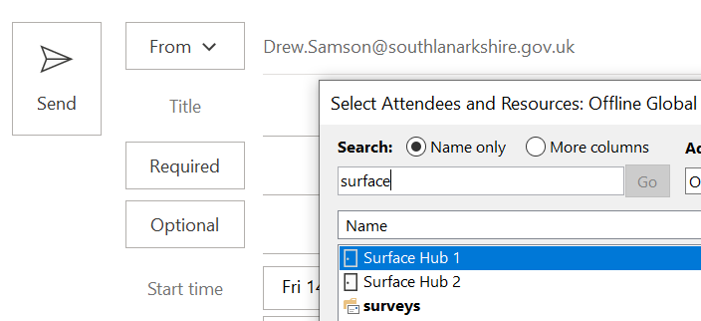
Microsoft Teams: Invite Surface Hub to a Teams meeting
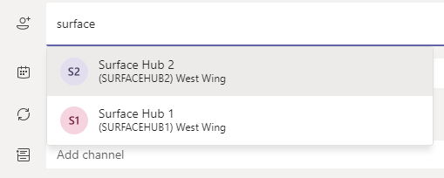
If the requested Surface Hub is available at your chosen time, the invitation will be automatically accepted. Consequently, the request will be declined if the required device in unavailable.

Starting a meeting on Surface Hub
Starting a meeting with Surface Hub is easy. Whether you scheduled the meeting in advance and reserved the Surface Hub or walked into the room for an ad-hoc meeting, Surface Hub is ready for you at the Welcome screen.
Scheduled Meetings | Ad-Hoc Meetings
- From the Welcome screen, tap the scheduled meeting you want to attend  - Choose Join | - From the Welcome screen, tap Call  - Tap Meet Now and the use the Invite Someone search box to look for attendees  - Once you have your list of people, tap on Start Meeting
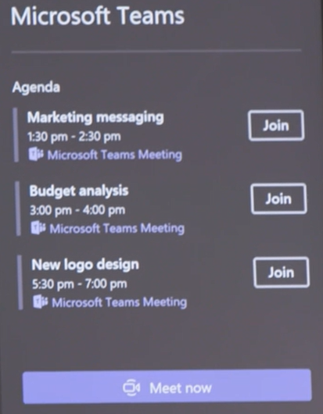 | 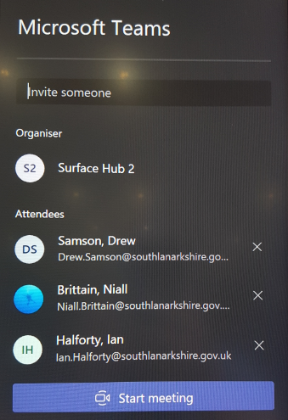

Full screen view
Once you have joined a meeting, you will see the video feeds of the other participants in the Teams pane on the right side of the screen. To expand the incoming video to fill the entire screen, tap the Full screen icon at the bottom of the Teams pane. Use the same button again to exit full screen mode.
Move the Teams pane
By default, the Teams pane appears on the right side of the screen. If you prefer to switch it to the left side, touch near the top right corner.
Add someone to a meeting
To add someone to the meeting:
- Hit Add people at the bottom of the Teams pane (located next to the full screen button)
- Start typing the person’s name in the text field and a list of options will appear as you type
- When you see the person you are looking for, tap their name to add them
Connect your laptop to Surface Hub
Surface Hub enables you to connect external devices and you can display content from your devices to Surface Hub.
Action: Wirelessly connect your laptop to Surface Hub
 | What you do |  |  | Comments/Prompts
- From your laptop’s keyboard, press and hold the Windows key and tap the letter K |  |  | 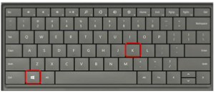  The wireless connection window is displayed
- Select the Surface Hub you want to connect to |  |  | You can find the name of the Surface Hub in the bottom left corner of the screen  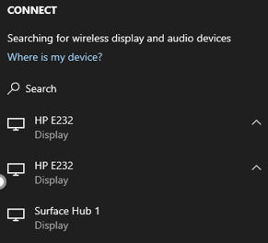  In the screenshot above, Surface Hub 1 is used as an example
- Select the Allow mouse… check box |  |  |   When this option is activated, you’ll be able to use touch and inking on the Surface Hub to control and make changes on your own connected device
- If required, click the control notification that appears in the bottom right of the screen of your laptop |  |  | This will allow control of your laptop from the Hub

Sign-in to your Office 365 account
The Surface Hub is auto signed in with its own Office 365 account that gives it access to the Office 365 applications and features. It is possible to sign into your own Office 365 account on the device to gain access to your Microsoft Teams app or OneDrive to view your files. To do this:
- Tap the Sign in to see your meetings and files option on the Welcome screen
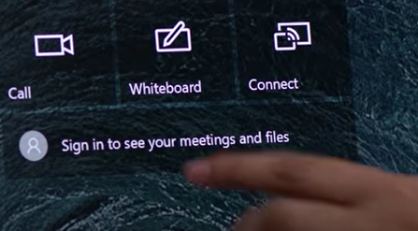
- Enter your work email address and password. You will then be able to access your own files and features

Notes:

The Surface Hub is intended for group use, not as a personal device. Therefore, the system gets wiped clean after every session

The device wasn't designed to store data, and it is not meant to be used as a repository for files and applications

To retain any data you create with Surface Hub during meetings or when working on files, first sign-in and then save your work to OneDrive

Start menu
At any time, you can press the Windows icon  at the bottom of the screen to go to the Start menu. Use the menu to access the whiteboard, start a Teams call, and open apps such as Word, Excel, and PowerPoint. The commonly used apps are displayed on the Start screen, but you can display an alphabetical list of apps stored on the Surface Hub by selecting All apps.
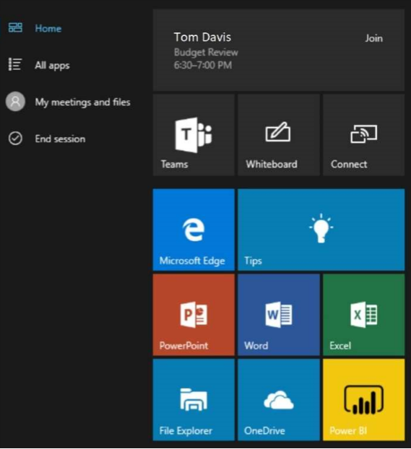

Switch or Close Apps
Select Task View  at the bottom of the screen to switch between open apps and to close any open app.

Tips App
The Tips app  located on the Start screen is a great way to get up to speed on your Surface Hub fast. Consult it any time you need to know how to perform a task on your Surface Hub.

End the Surface Hub session
Surface Hub is designed to provide users with the same fresh experience for every session. The best way to start with a fresh session is to save all work and end the session. This can be helpful if you want to reset for the next group or just need a fresh start.
- Press End session at the bottom of the screen to display the 10-second countdown timer

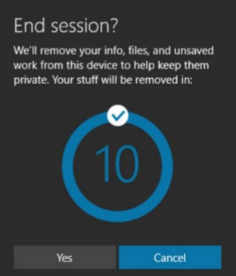
If you need to cancel the countdown for any reason:
- Tap anywhere else on the screen or press Cancel
- To skip the countdown and immediately end the session, press the Check mark, or press Yes
After a few seconds, the welcome screen will be displayed, and the device is ready for the next session

Note:
Ending the session will remove anything you have saved to the device, close anything you are working on, and sign you out of any accounts. Therefore, ensure you have saved any content that you want to keep to your own OneDrive prior to ending the Surface Hub session.
Resume a Session
If you forget to end your meeting or need to leave a meeting running on Surface Hub during a break, the session goes to sleep but does not time out or reset automatically by default. The next time someone enters the room, the Welcome screen appears with a prompt to resume the meeting. This means that all the files and information from your meeting will be available when the meeting resumes.
End the Surface Hub session FAQ
What information is cleared from the Surface Hub when I select End session?
At the end of a meeting, users can tap End session to clean up any sensitive data and prepare the device for the next meeting. Surface Hub will clean up, or reset, the following states:
- Applications
When you start apps on Surface Hub, they are stored in memory and data is stored at the application level. Data is available to all users during that session (or meeting) until it is removed or overwritten. When End session is selected, Surface Hub application state is cleared out by closing applications, deleting browser history, and resetting applications. Applications are returned to their first-run state for the next group that uses Surface Hub.
- File System
Meeting attendees have access to a limited set of directories on the Surface Hub. When End session is selected, Surface Hub clears these directories:
- Music
- Videos
- Documents
- Pictures
- Downloads
Surface Hub also clears these directories, since many applications often write to them:
- Desktop
- Favorites
- Recent
- Public Documents
- Public Music
- Public Videos
- Public Downloads
What happens if I forget to tap End session at the end of a meeting, and someone else uses the Surface Hub later?
Surface Hub only cleans up meeting content when users tap End session. If you leave the meeting without tapping End session, the device will return to the Welcome screen after some time. From the Welcome screen, users will then have the option to resume or end the previous session.
Are documents recoverable?
Removing files from the hard drive when End session is selected is just like any other file deletion from a hard disk drive. File recovery is not a supported feature on Surface Hub. To prevent data loss, always save the data you need before leaving a meeting.
What if I forget to stop recording my Teams meeting?
You can record any Teams meeting or call to capture audio, video, and screen sharing activity. Be sure to stop the recording of your meeting before ending the Surface Hub session. If not stopped, the recording automatically continues and ends after four hours.
Device Troubleshooting
Connectivity issues
Like any piece of electronic equipment, the Surface Hub will experience interruptions in performance or be affected by connectivity issues.
If the Surface Hub freezes, restart the device:
- Press the ^ menu in the bottom right corner of the screen
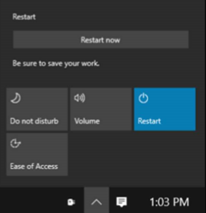
- In the menu, choose Restart
- Select Restart Now
Keep in mind that there is no 10-second countdown and the device will immediately restart which means any unsaved work will be lost.
If the Surface Hub loses connection during a Teams meeting:
- On the Surface Hub Welcome screen, tap the meeting and choose Join. You may also be able to Join from the Teams panel if it remains displayed on the Surface Hub screen
OR
- The meeting organiser should access the Participants list, place their mouse pointer on the Surface Hub entry and select the Request to join option
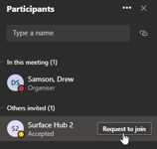
A request to re-join the meeting is then displayed at the bottom right of the Surface Hub screen. Tap Video and the Surface Hub will re-join the meeting.
Troubleshoot apps and device features
Getting work done with Surface Hub is easier than ever with multitasking and video conferencing at your fingertips. There are some simple ways to keep everything running optimally for end users:
- Remember to always save your work
- The best way to make sure your work is saved is to utilise Office 365 and Microsoft OneDrive for file access
- While users are signed into Office 365, files and whiteboards will be saved automatically to their profile
Restart apps
During normal use, an app on Surface Hub may not behave as expected. The quickest way to fix an issue with a specific app is to close and relaunch the app.
- Press the Task View button to display all running apps, including those that may be running in the background
- Press the X to close any apps you no longer need as well as the app that isn’t behaving as expected
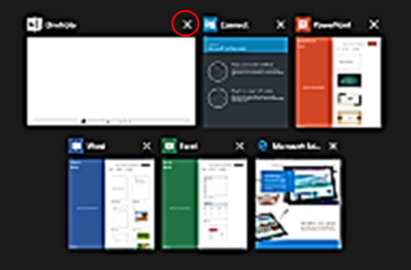
- Open the Start Menu to re-launch any apps that you need. If you saved your work, you will be able to continue right where you left off
Keep in mind that there is no 10-second countdown and the device will immediately restart which means any unsaved work will be lost.
Power off/on
To power off a Surface Hub:
- Press the Power button located on the bottom of the device
- Unplug the device from the wall and the battery (if connected)
- Wait about 10 seconds and then plug the power back into the device. The device will turn on and boot up to the Welcome screen
Additional Resources
YouTube video: Introducing Surface Hub 2S
Short introductory video produced by Microsoft
YouTube video: What is the Surface Hub2S?
Detailed first look and demo from the engineering team behind Surface Hub 2S
YouTube video: Surface Hub 2S Microsoft Teams Experience
Connect and collaborate from anywhere using Microsoft Teams on Surface Hub 2S
YouTube video: Sign In To See Your Meetings and Files
Sign in to your Surface Hub 2S to see your meetings and access your Office 365 files
YouTube video: Connect and Project From Your Device
Learn how to project to your Surface Hub 2S using Miracast or display cables
Microsoft website video: Navigating Surface Hub 2S
Video training exploring various features of Surface Hub 2S. Topics include:
- Welcome screen
- Start menu
- Full screen
- Clip to Whiteboard
- Task bar menu
- Teams/Skype
- End Session
Microsoft website video: Whiteboard collaboration
Introduction to the Whiteboard app for Surface Hub 2S. Topics include:
- Starting the Whiteboard
- Whiteboard tools
- Changing the background
- Sharing the whiteboard
- Exporting the whiteboard
Microsoft website video: Microsoft Teams meetings
Video training for Surface Hub 2S with Microsoft Teams meetings. Topics include:
- Introduction to Microsoft Teams
- Scheduling Microsoft Teams meetings
- Starting a meeting
- Starting an ad hoc meeting
- Joining a meeting on your calendar
- Managing a Microsoft Teams meeting
- Presenting content

Microsoft website video: Explore Surface Hub apps
Video training exploring common Surface Hub 2S apps. Topics include:
- Surface Hub apps introduction
- Microsoft PowerPoint
- Microsoft Word
- Microsoft Excel
- Microsoft Edge

