Objective Quick Guide
Search for a service user using Objective Navigator
When you open Objective to search for a service user press control CTRL F, you may get the screen below? Click on ‘switch to query’
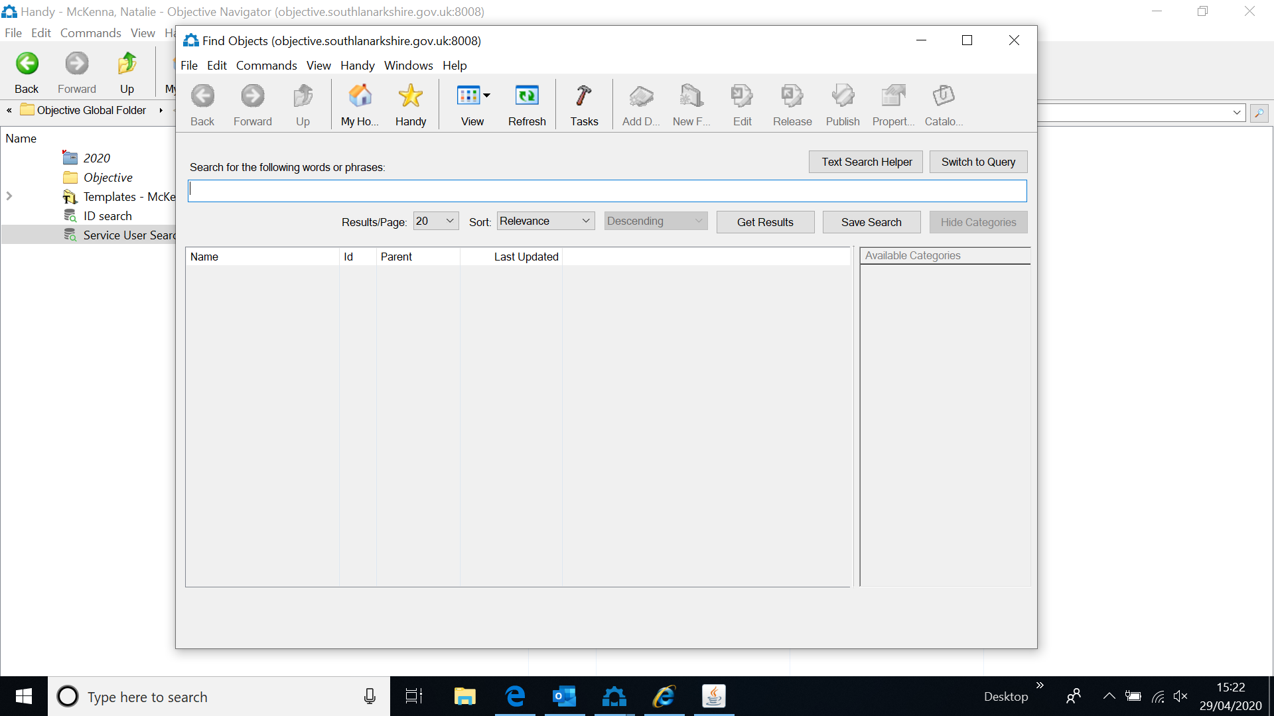
You should now get the below box
Tick box ‘show properties to query’
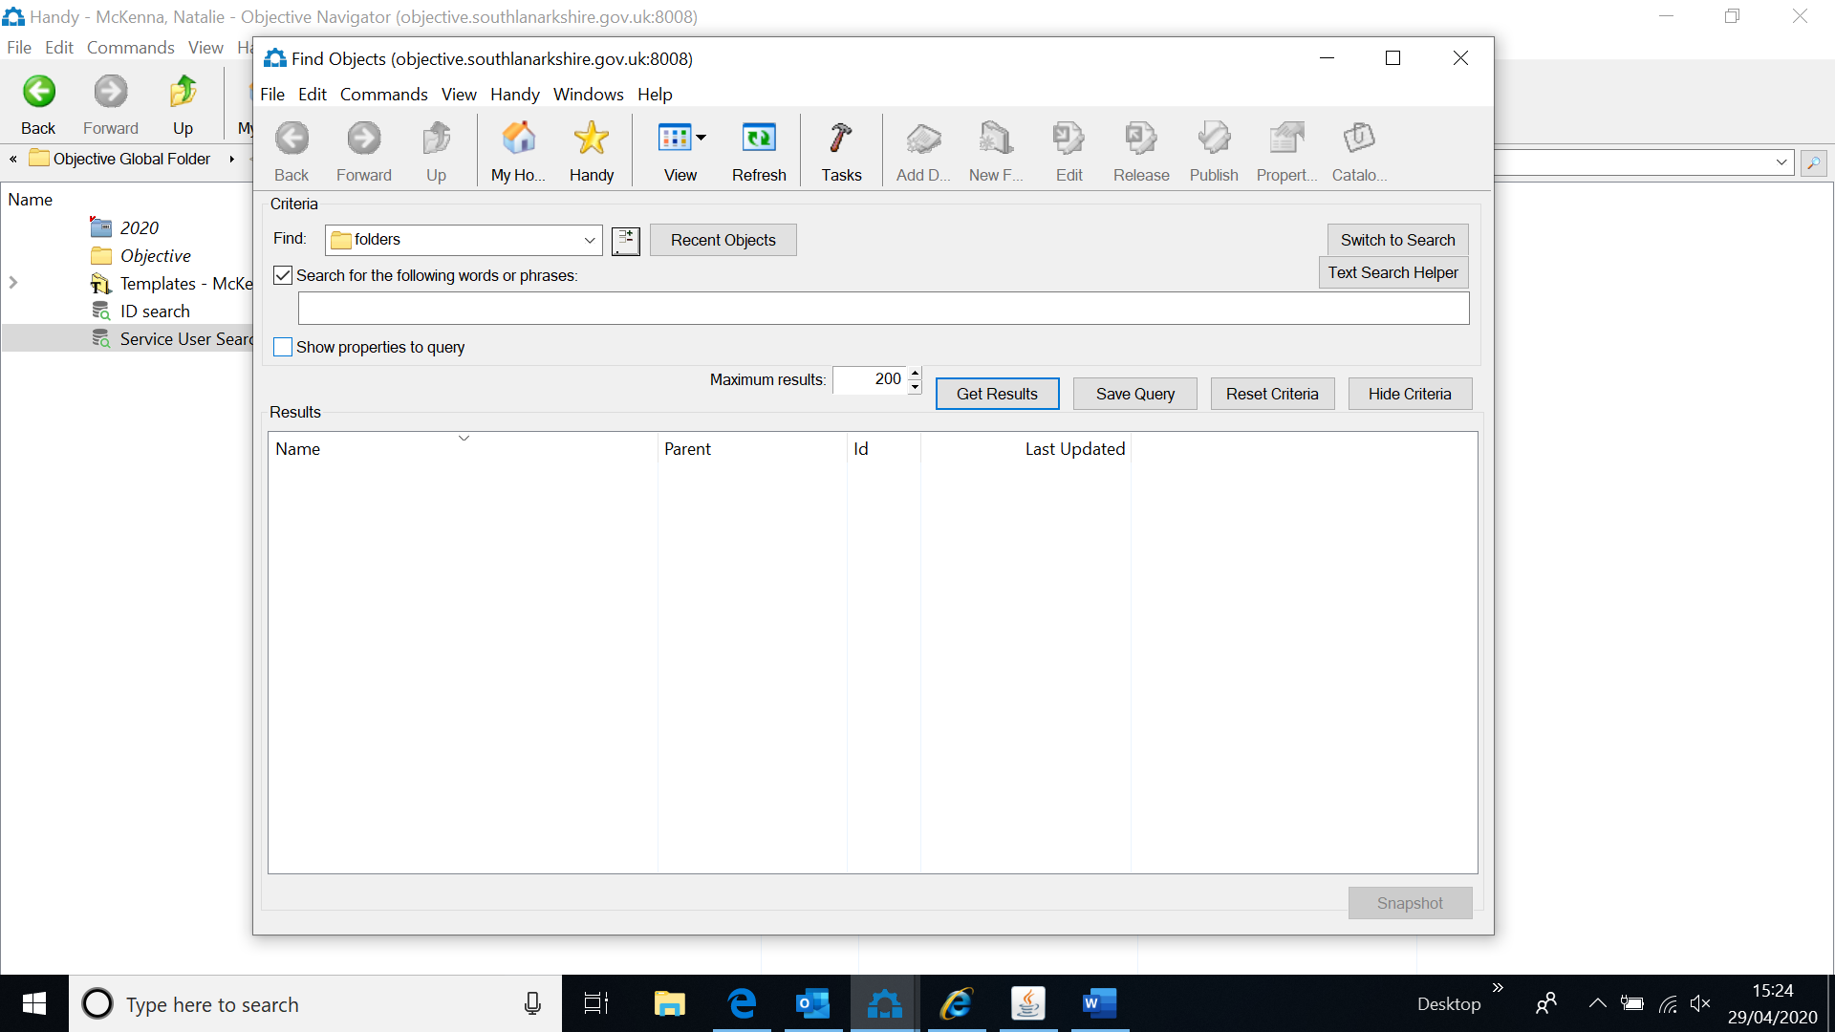
The below box will appear
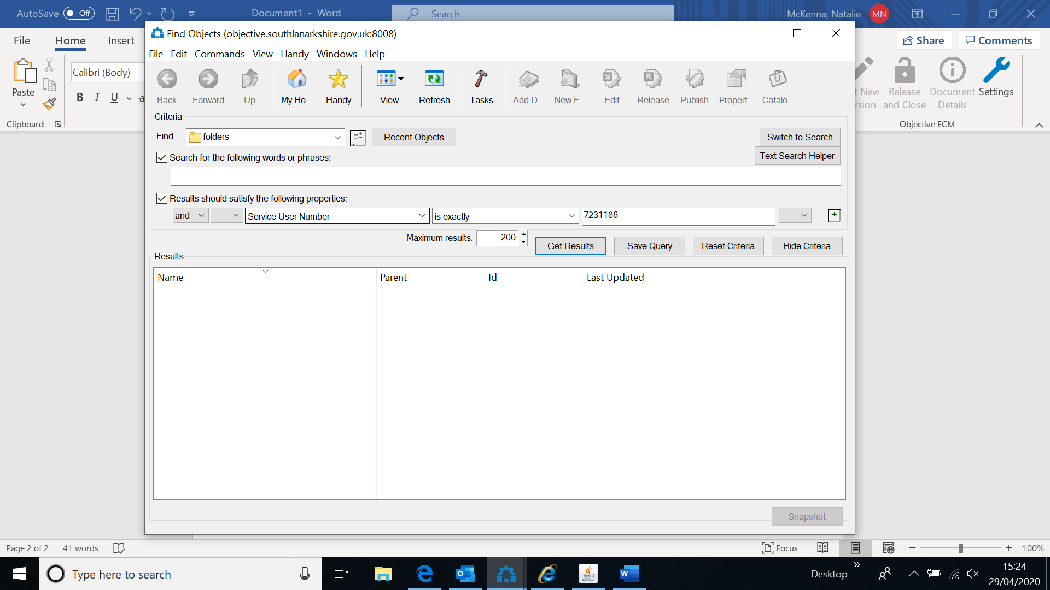
Change the first drop down box at find to ‘folders’
Then the 3 boxes in a row have drop down menus in the first select ‘service user number’ the second box select ‘is exactly’ and in the third you will enter the SWiS no of the service user, then either select ‘get results’ or hit enter on the keyboard and this will find your service user. Double click on their name and this will take you into the file plan
Saving a document to Objective
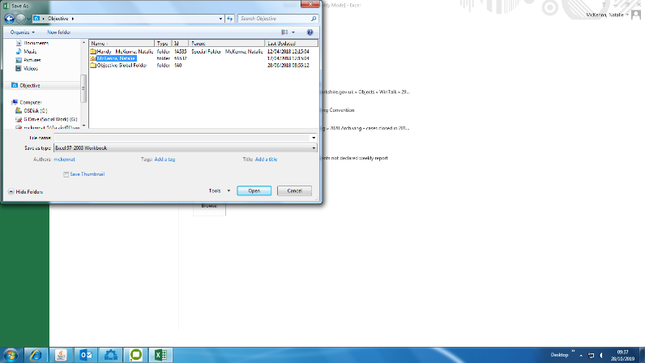
Click File
Save as
Browse
Click Objective on the left-hand side
Then double click on to the folder highlighted below (your name

The below box will appear then click save
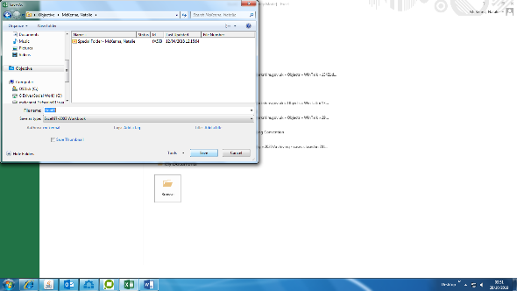
The below pop up box may appear at this point asking if you want to change the type – say yes to this.
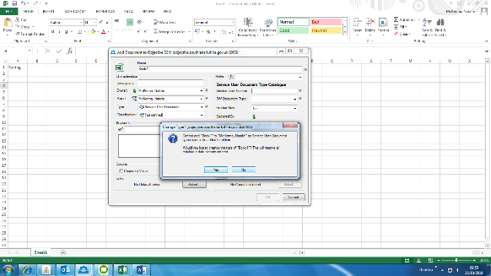

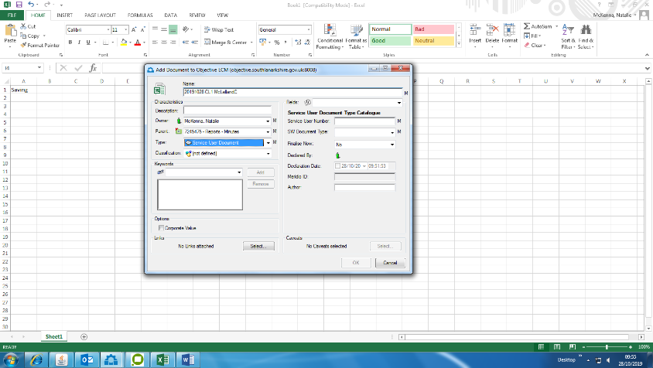

There are mandatory fields that need to be completed before this can be saved
Name – the title of the document it should look like 20191028 Bail supervision appointment letter McKennaN (always date backwards then what the document is and your surname and initial- no service user details should be in the title i.e. name, swis no or address)
Then in the parent box you should type the swis no and press the tab key (the button above cap lock) this will then bring up the folders and you choose which folder you want to save this into.
Type- should always be service user document

Service user document - confirm the service user number (swis no)

SW document type and this is the folder you chose to save this into

Finalise now – if you are finished with the document and don’t need update this then select yes – if its something you will be working on then select no

Then click OK

When you close the document a pop up box will appear asking to release or keep in edit – always click release.
Drag and drop into Objective.

Locate the service user file plan

Once you have located the file plan, the best way to drag and drop is to split your screen.

To split your screen, press the windows key on the keyboard (this is the key between ctrl and alt) and then press the arrow across key (either way). If the document, you want to drag and drop is within your emails then do the same process with outlook.

Your screen should look like the below. From here you would click on the attached document using the left hand button on the mouse and keep this pressed in and drag the document over to the folder you wish to save into

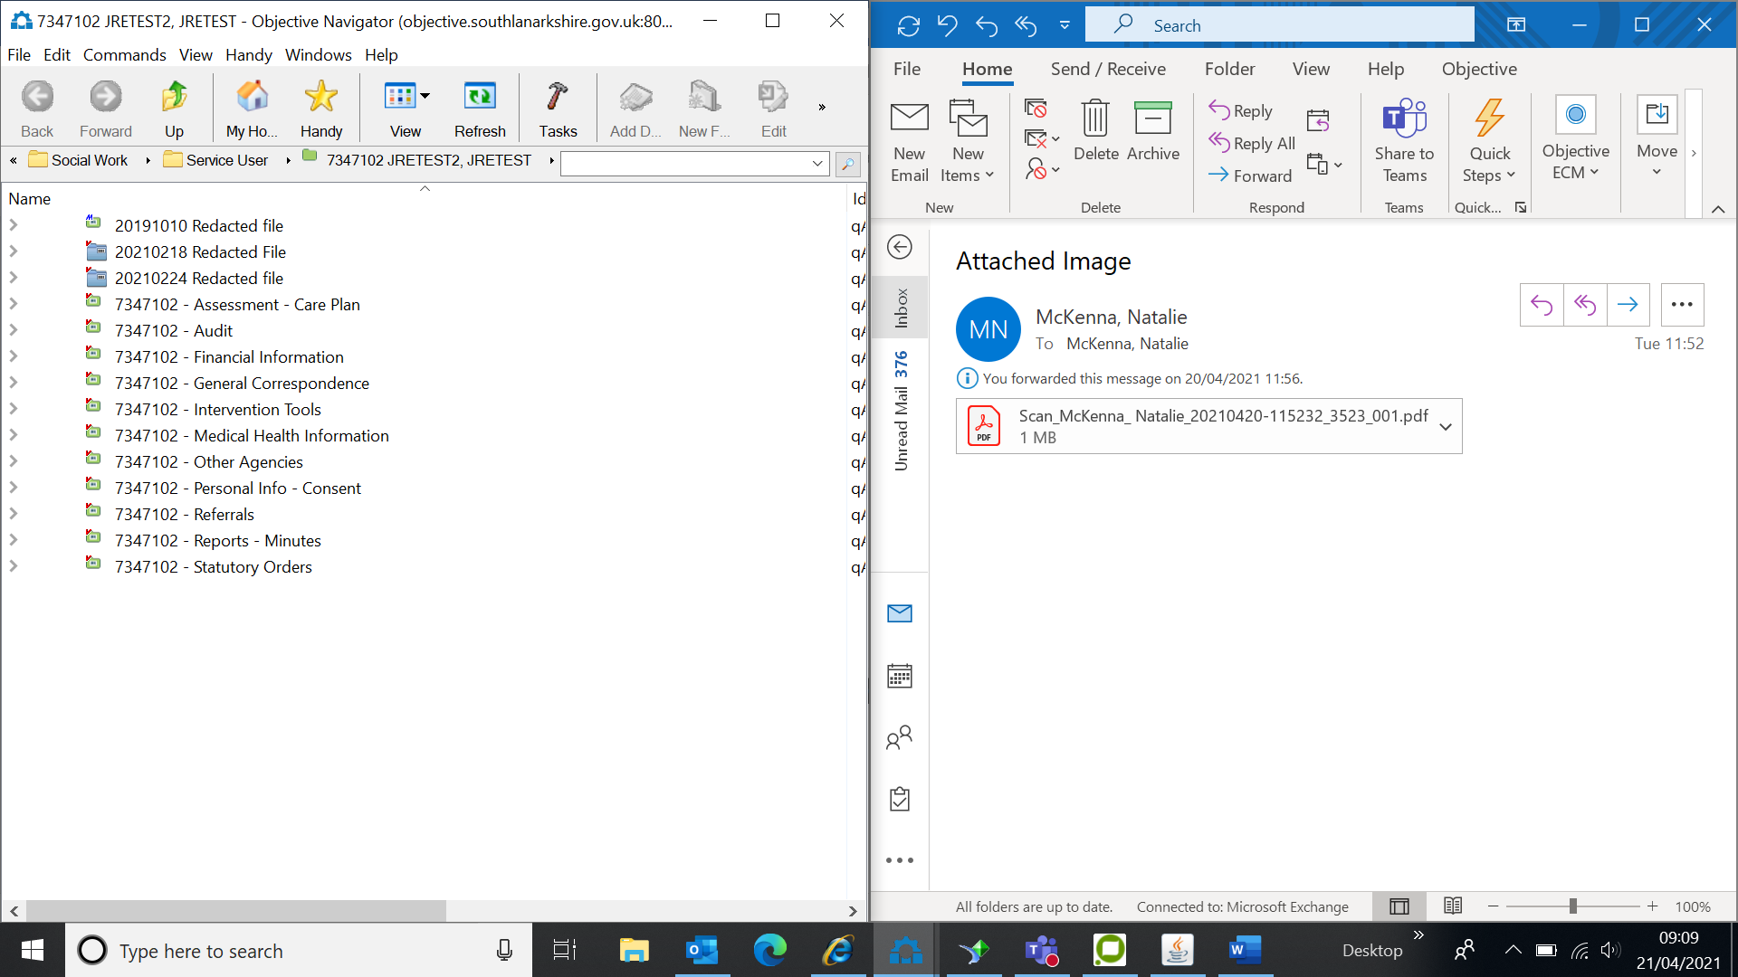

The below pop-up box will appear. You have mandatory fields to complete here before it will allow you to save.
If another pop-up box appears advising you it can’t save and do you want to change the type of document say yes.
Name – the title of the document it should look like 20191028 Bail supervision appointment letter McKennaN (always date backwards then what the document is no service user details should be in the title i.e. name, swis no or address)
Type – click on the drop-down box and select service user document.
Service user number – this is the SWiS no
SW document type – confirm which folder you are saving this into
Finalise now – If you are finished with the document and know you won’t be making any changes then select yes. If it’s something you are working on for example a report and you are not finished select no as this allows you to go back in and edit the document.
Ensure the publish documents immediately box is ticked.
Then click save
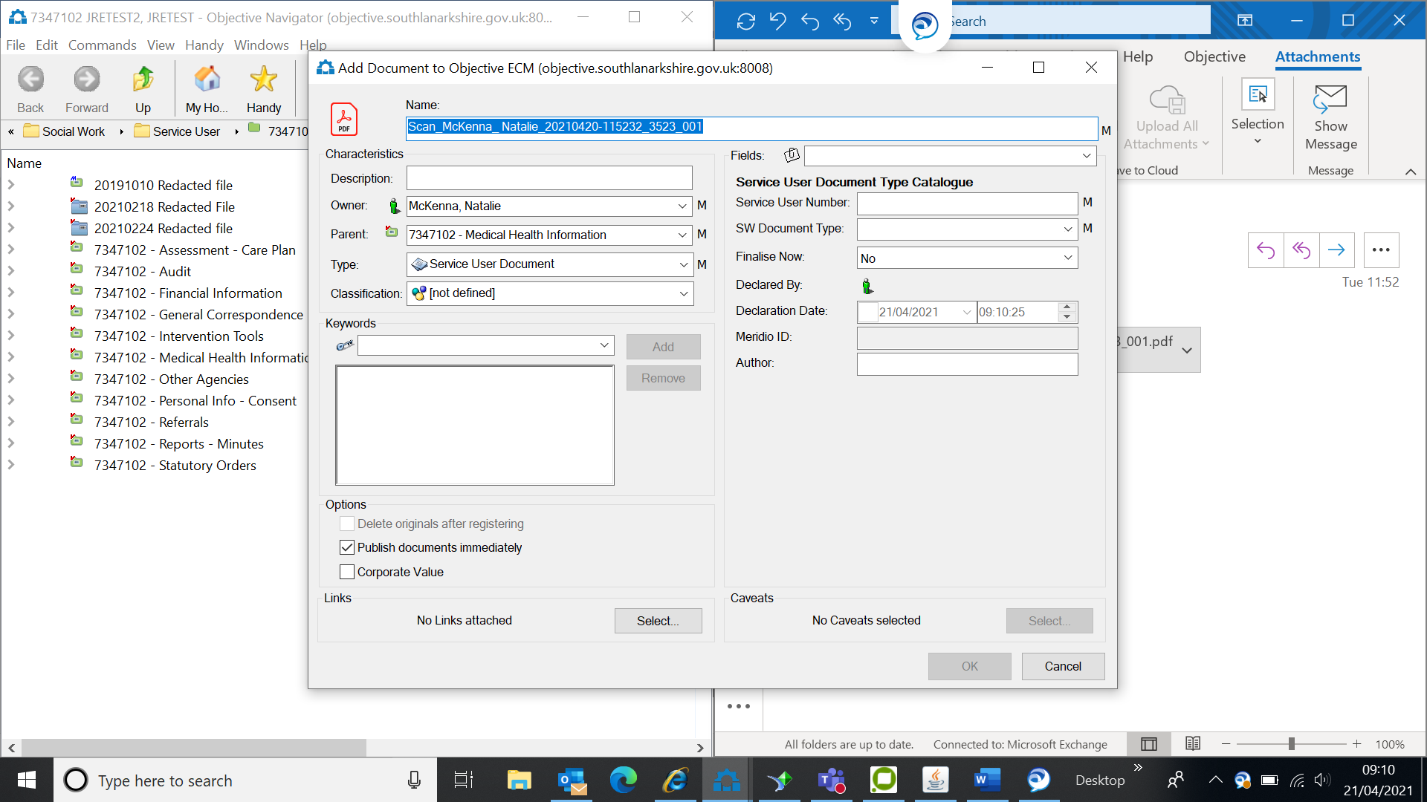
When you close the document, another pop up box will come up can you always ensure you click release.

Finalising a document

Go into Objective Navigator on the desktop – you will be automatically logged in

When open press CTRL F

The below box should appear
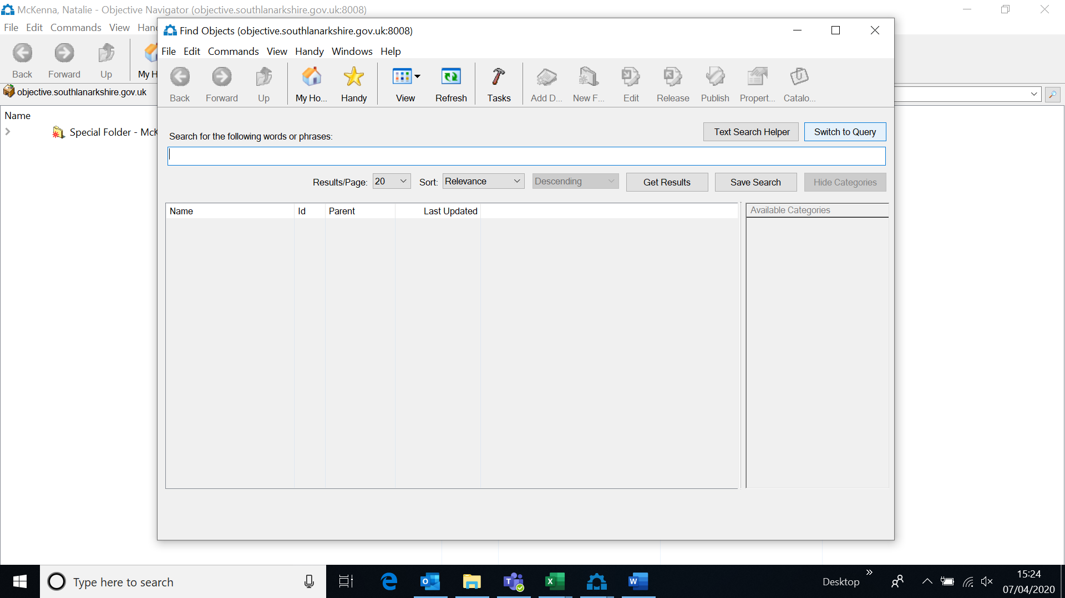
Click on the box that says ‘switch to query’

The below should then come up

Tick the ‘show properties to query’
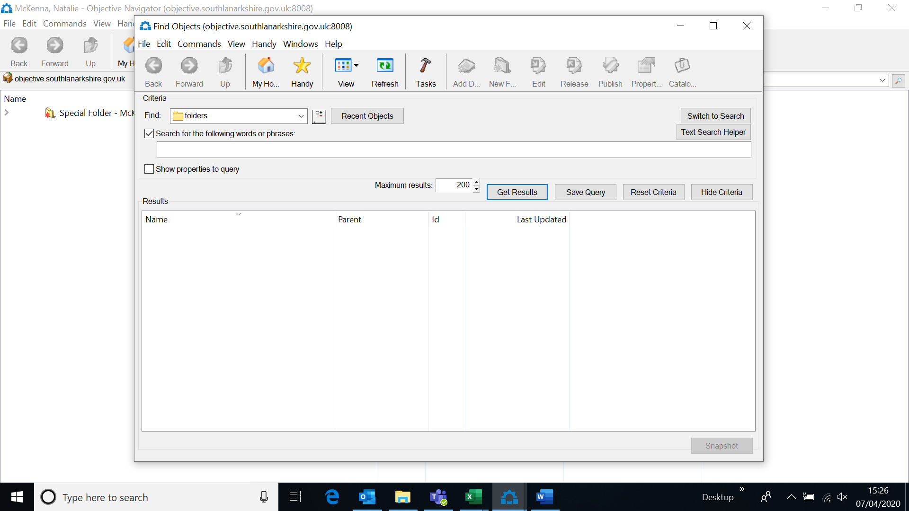
You will then get the below
Select show properties to query

Change the drop-down boxes to the below:
Find – change this to documents
The first drop down box select object id, the second drop down select is
In the blank box put the ID number this is the A number
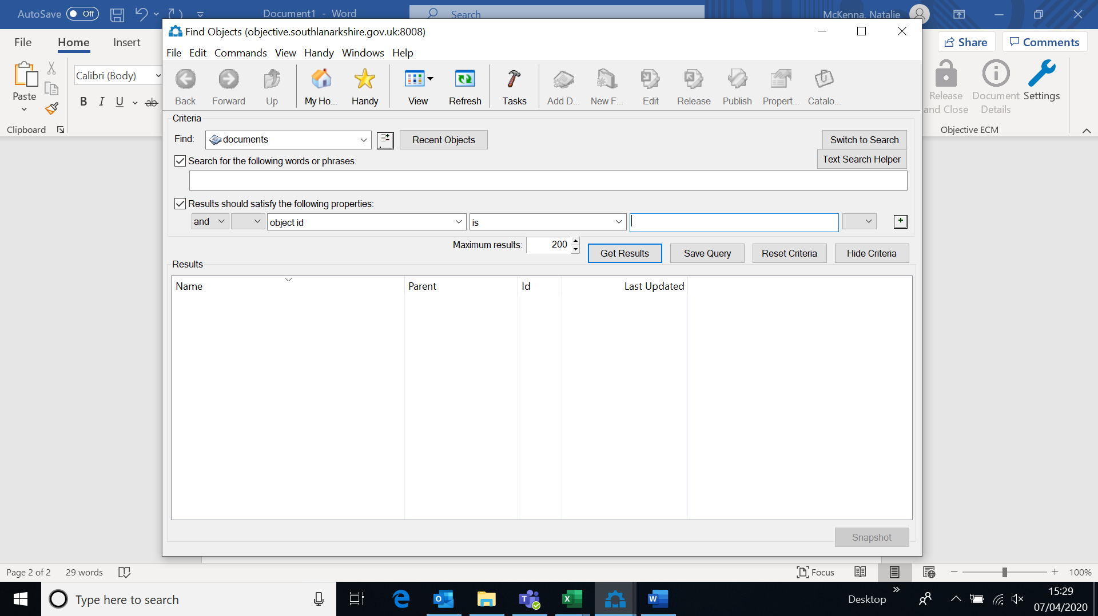
This will find the document you then right click on the document and go to casework flow, then finalise document.

