Curriculum and Quality Improvement Service

South Lanarkshire Council


Education Resources

SEEMIS Tracking and Monitoring Notes

Guidance Note 7 Making changes to class teachers after turnaround

These instructions have been designed for Primary schools to make changes to their Class teachers after turnaround

To check the teachers that have been allocated to classes log into Tracking and Monitoring.
Maximise the screen
Click on Teacher View
Click New List
On the panel that appears on the left of the screen, hold the mouse over the right edge. When a double arrow symbol appears, left click the mouse and drag the the panel across the whole screen. This will permit you to see all the teachers attached to all your classes. If there are any changes required note the changes and follow the appropriate steps outlined below

Log into Click+Go ( Not Tracking and Monitoring)

HOW DO I ADD A TEACHER TO A CLASS?

Application
This Session
Timetable
Classes
Set Up Classes

- Select the year/stage from the drop down list
- Select ‘All Classes For This Stage’
- Click NEW LIST
- Select appropriate class
- Click STAFF ATTENDING on the left hand side of the screen
- Click SELECT ALL
- Select the teacher to be assigned from the drop down list
- Click ADD TEACHER
- Click PROCEED
- Click YES to continue
- New teacher will now be allocated to the class

HOW DO I CHANGE A TEACHER THAT IS ALLOCATED TO A CLASS?

Application
This Session
Timetable
Classes
Set Up Classes

- Select the year/stage from the drop down list
- Select ‘All Classes For This Stage’
- Click NEW LIST
- Select appropriate class
- Click STAFF ATTENDING on the left hand side of the screen
- Click SELECT ALL
- Select the teacher to be assigned from the drop down list
- Click REPLACE STAFF
- Click PROCEED
- Click YES to continue
- New teacher will now be allocated to the class

HOW DO I ADD AN ADDITIONAL TEACHER TO A CLASS?

Application
This Session
Timetable
Classes
Set Up Classes
:
- Select the year/stage from the drop down list
- Select ‘All Classes For This Stage’
- Click NEW LIST
- Select appropriate class
- Click STAFF ATTENDING on the left hand side of the screen
- Click SELECT ALL
- Select the teacher to be assigned from the drop down list
- Click ADD TEACHER
- Click PROCEED
- Click YES to continue
- New teacher will now be allocated to the class

The following procedure must be carried out after you have made any changes to the teachers attached to classes. This will transfer the updated data to Tracking and Monitoring

Log into Click+Go ( Not Tracking and Monitoring)

Follow the menu route

Application
Data Utilities
Access Control
Add Current Classes – All Staff

The following screen will appear

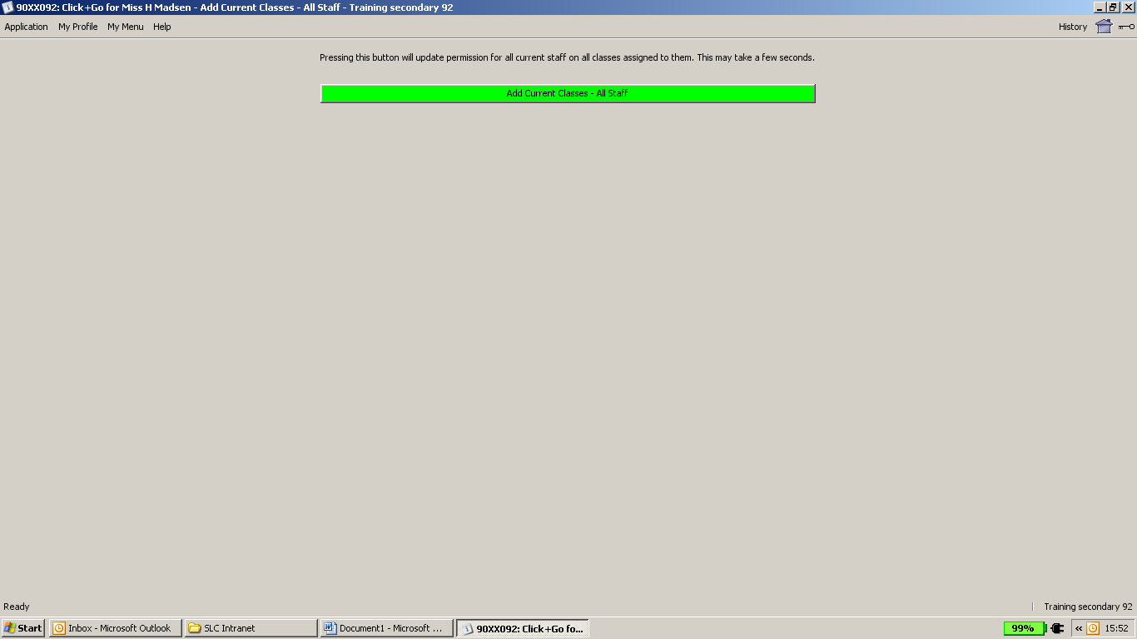

Click on the bar that says Add Current Classes –All staff

When the box below appears Click Yes

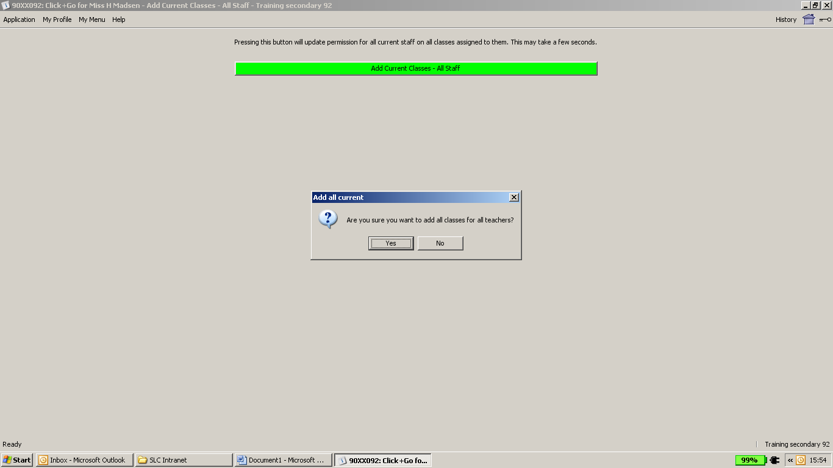

After this has been done you can close Click+Go

