Curriculum and Quality Improvement Service

South Lanarkshire Council


Education Resources

SEEMIS Tracking and Monitoring Notes

Guidance Note 3 Tracking Period Setup

Log into SEEMIS

Select Tracking and Monitoring

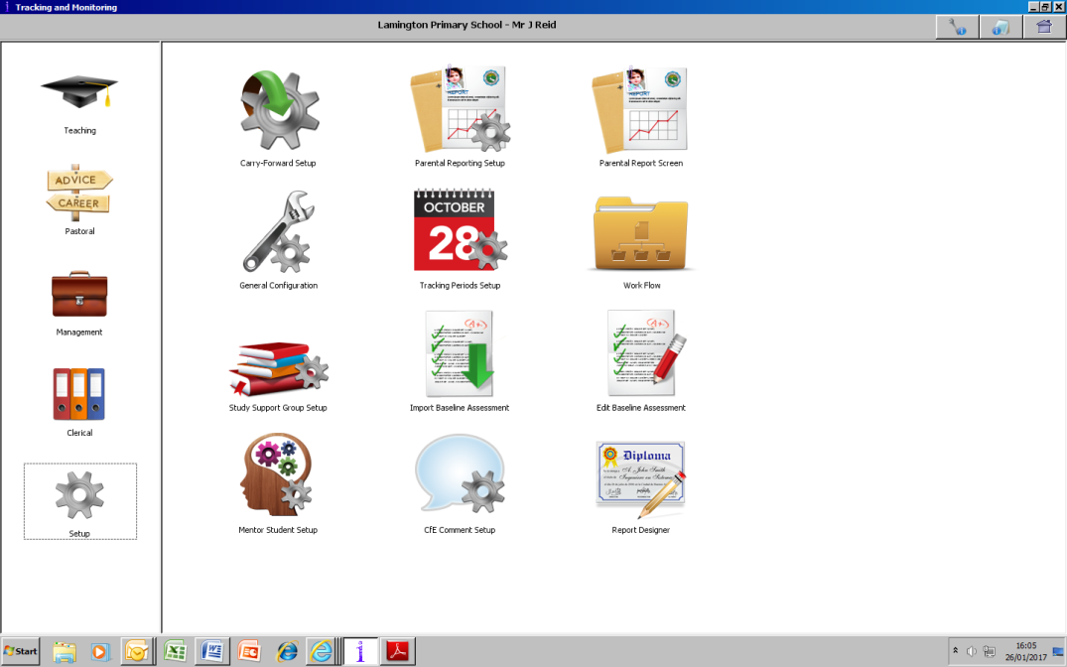

In the left panel Click on Set up

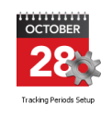
Then click on Tracking Period Setup

Select the appropriate stage

Click the padlock next to the month to be edited then click the following columns for this month

Month
Allow Edit
Parental Report
Allow Action Plan Edit

In the Report used box select the report SLC NEW Primary CfE report

You only need to set up ONE month for Reporting This should be the month in which you intend to issue your reports Once staff start entering data this month can't be changed

Once you have set up the month staff can start entering data As mentioned above you only need to select ONE month DO NOT tick every month from when you set it up until your reporting month Someone gets this one wrong every year !!! It can be fixed but means extra work for your staff

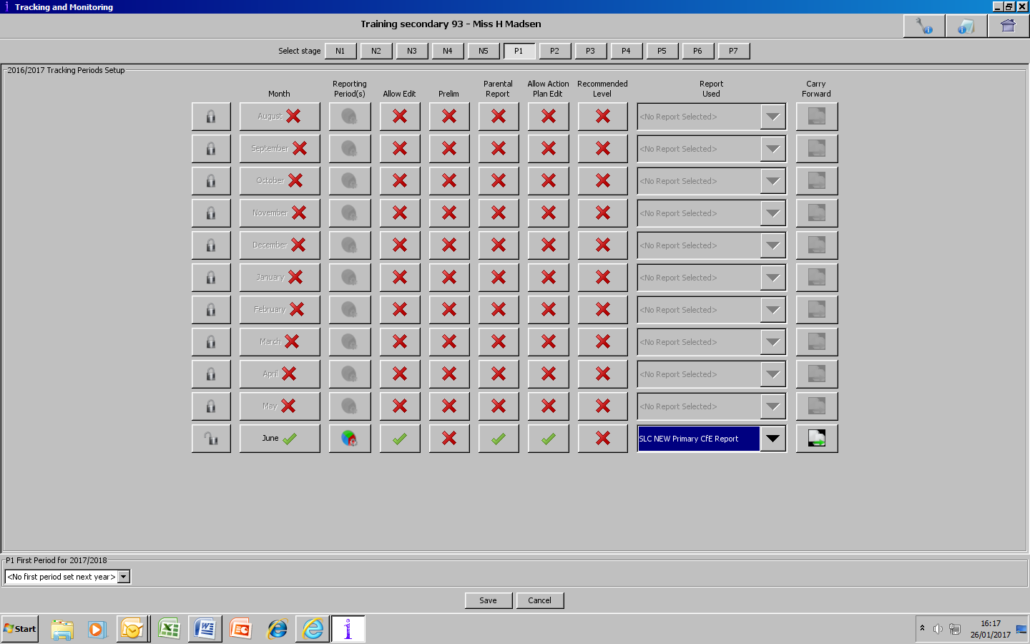

Click Save

Repeat for all other stages

