

Finance and Corporate Resources
Finance Services

Title: Willow Gate Accommodation

Date written: June 2026

Review date: June 2028 Version: 26.02

Contents Page

1. Introduction 2
2. Eligibility for Housing Benefit 2
3. Application for Housing Benefit received 2
4. Maximum rent used to assess Housing Benefit 3
5. Checks required before processing the Housing Benefit application 3
6. Checking Willow Gate occupancy dates 3-5
7. Processing the Housing Benefit claim 5-6
8. Attributes Screen 6
9. Claim Basis 7
10. Tenancy Details 8
11. Tenancy Details - Part 2 8
12. Tenancy Details - Part 3 9
13. Loading the Rent Officer referral details 9-10
14. Calculation Screen 10
15. Retrospection Screen 11
16. Further Information 11

Record of Amendments 12

1. Introduction

1.1 Willow Gate, located in Hamilton, is emergency accommodation managed by Right There. The property was formerly the Clydesdale Hotel. The address is 12 Clydesdale Street, Hamilton.

1.2 Willow Gate opened on 1 June 2026 and provides accommodation to homeless claimants, ideally for a 28-day period (but this could be shorter or longer) and Right There will provide them with a high level of support to develop the skills to live independently in their own tenancy.

1.3 There are 12 single/couple occupancy rooms which have an en-suite bathroom and there are 3 family suites which are self-contained designed for families.

1.4 This procedure outlines the process for dealing with applications for Housing Benefit (HB) from claimants within Willow Gate.

2. Eligibility for Housing Benefit

2.1 As the tenants will receive a high level of support to give them the skills to live independently and this support is provided by the landlord (who is a charity), the accommodation is classed as supported (exempt) accommodation.

2.2 This means the tenants are eligible to claim Housing Benefit (HB) even if they are in receipt of Universal Credit except any full-time student not in receipt of UC and not in one of the vulnerable groups.

NB: Please refer to Students – Eligibility Desk Aid for details of the vulnerable groups

2.3 Full time students
If there is no UC claim but the student falls within one of the vulnerable groups, HB can be paid as they are eligible for HB.

If UC has been claimed, the claim should be pended waiting on the UC decision to determine if the claimant is in a vulnerable group and eligible for HB. If the decision is:

- UC awarded: Eligible for HB.
- UC refused as ineligible: HB is ineligible and claim must be terminated

2.4 Claimants HB eligibility ends when they leave this accommodation unless they move to other temporary or supported accommodation or are state pension age.

3. Application for HB received

3.1 As part of the tenant’s support, Right There assist the tenants on applying for HB and are trained on the evidence required to support the application.

3.2 Most of the verification for these claims can be done in-house. However, if evidence is required to be provided by the tenant, this should be requested following normal verification processes. The verifying HB claims procedure details the evidence required and how this can be obtained.

NB: Due to the tenant’s vulnerabilities, if additional evidence is required and cannot be verified in-house, you may be required to give them longer to provide this. Each case should be considered on an individual basis, and we are also able to contact Right There to assist in providing us with the evidence required.

4. Maximum Rent used to assess HB

4.1 HB is assessed based on the maximum rent figure provided by the Rent Officer.

4.2 Normally, we are unable to pay above the maximum rent figure provided by the Rent Officer but with supported accommodation, the local authority is not bound by this and can pay HB based on the full contractual rent.

4.3 The local authority can only receive 100% subsidy on the HB paid based on the Rent Officer determination. We will only receive 60% subsidy on any HB paid above the maximum rent.
Example
Joe lives in one of the single rooms in Willow Gate. The contractual rent is £585 per week, and this includes all eligible service charges.

The Rent Officer makes a determination that the maximum rent is £185 per week.

Joe is in receipt of UC and receives maximum HB. The local authority receives 100% subsidy on £185 per week and 60% subsidy on £400 per week.

4.4 The Rent Officer referral procedures detail the full Rent Officer referral process.

5. Checks required before processing the HB application

5.1 Prior to processing the HB claim, search using the NINO to check if they are on another claim. Tenants moving into Willow Gate may have previously been living in other temporary accommodation.

  - If they are claiming elsewhere, the claim should be terminated from the date moved.
  - If they are on another claim as a non-dependant, they should be ended from the date they left and check if the claimant is eligible for any Council Tax discount because of the non-dependant leaving.

5.2 Due to the frequency of movement within temporary accommodation, a decision may not have been made on a previous application. If there has been no decision made on the other claims, a termination line can be added to the benefit claim even if it is pending awaiting information.

5.3 Right There will provide occupancy details for any tenant that moves into or leaves Willow Gate. Check the relevant monitoring form to confirm the date the claimant moved into the accommodation.

6. Checking Willow Gate Occupancy Dates

6.1 To identify the dates the claimant is resident at Willow Gate, you need to check the occupancy list on Civica. The occupancy lists are saved under the claim reference ‘X4’. Right There email these to Benefits and Revenue on a regular basis.

6. Checking Willow Gate Occupancy Dates (cont/d)

6.2 To search for the occupancy details, access Civica and click on ‘Housing Benefit’ then ‘Benefit Claim Search’.
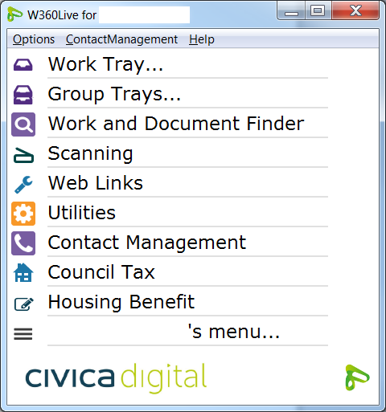

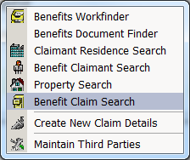

6.3 Type ‘X4’ in the ‘Claim Reference’ field and click on ‘Search’.
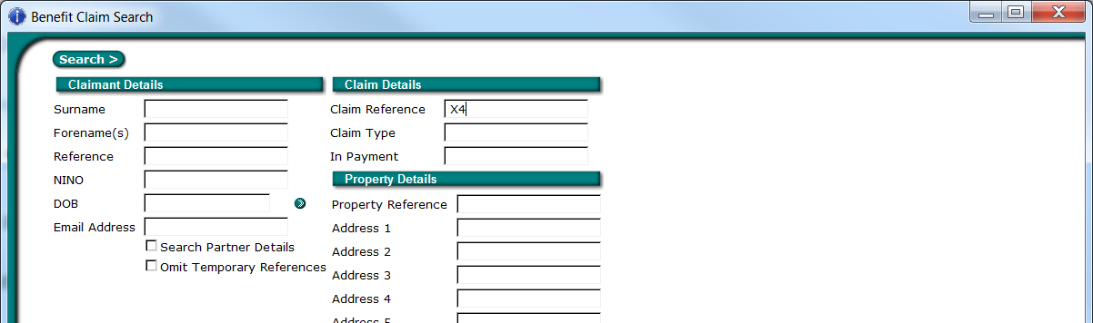

6.4 The full name will display as ‘Homeless Weekly Sheet’. Click on ‘Open’ to view the account.
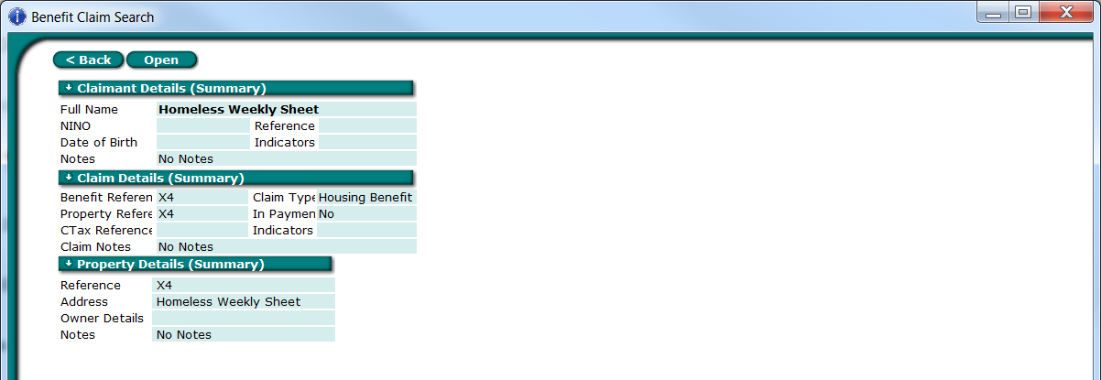

6.5 The X4 file contains occupancy lists from a number of different landlords (mainly where daily rents are charged). The ‘Title’ will detail which temporary units the sheets relate to; listed in date order so the most recent sheet will show at the top of the list.

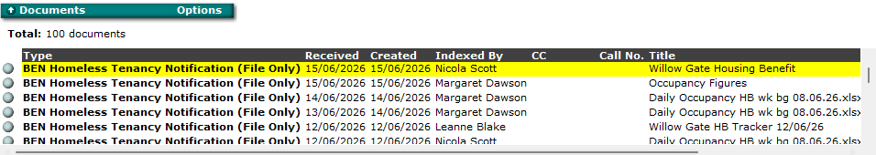

6. Checking Willow Gate Occupancy Dates (cont/d)

6.6 Click on the relevant line to display the email. Click on the attachment at the bottom of the email to view the occupancy list.

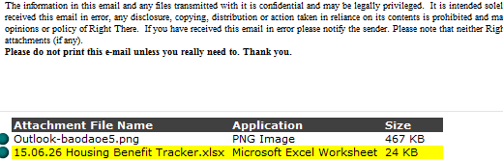

6.7 Willow Gate provide us with the following information:

- Name of occupier
- Room number they are residing in
- Date they moved in or out of the room
- If they are in receipt of benefits/working/full-time education

6.8 Right There email benefits to advise when an occupier has left the property. As a result, no room check referral is required.

7. Processing the Housing Benefit claim

7.1 New Claim
Search for the new claim using 12 Clydesdale Street. This will list all the rooms and family suites within Willow Gate.

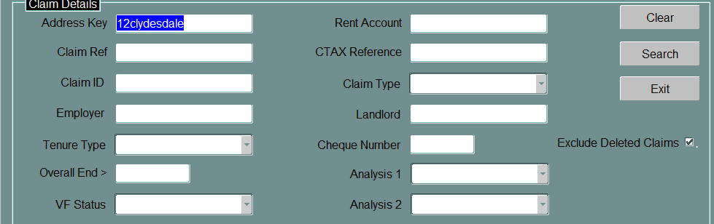

When you continue to search for the address, the source will be ‘UBS’ as manual addresses have been created for all the rooms.
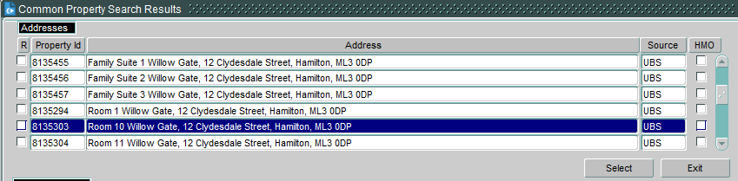

NB: There will be manual addresses for Clydesdale Hotel in the search criteria. These addresses must never be used.

7. Processing the Housing Benefit claim (cont/d)

7.2 Change of Address
The claim details can be copied over in the same way as general change of addresses. When you are searching for the current address, enter 12 Clydesdale Street in the search criteria.

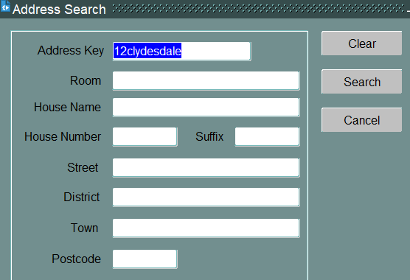

7.3 Claim pending at previous address
If the previous claim is still pending awaiting proof of income, you will need to create a new claim as you are unable to copy the claim details. A termination line needs to be loaded at the previous address. This is to stop overlapping liabilities between claims.
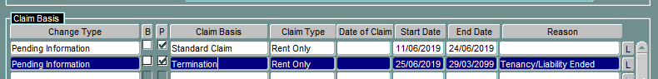

8. Attributes screen

8.1 Enter the attributes details as follows:

- Payment Cycle
This is ‘4-Weekly Arrears’
- Tenancy Type
This is ‘Private Tenant: Deregulated Tenancy (excluding HA/RSL)’
- Tenancy Start Date
This is the date the tenancy started
- Moved In
This is the actual date they moved into the accommodation (see Willow Gate monitoring form in the X4 folder to confirm occupancy dates).

8.2 You also need to select an option if temp/supported accommodation. Select ‘Supported’.

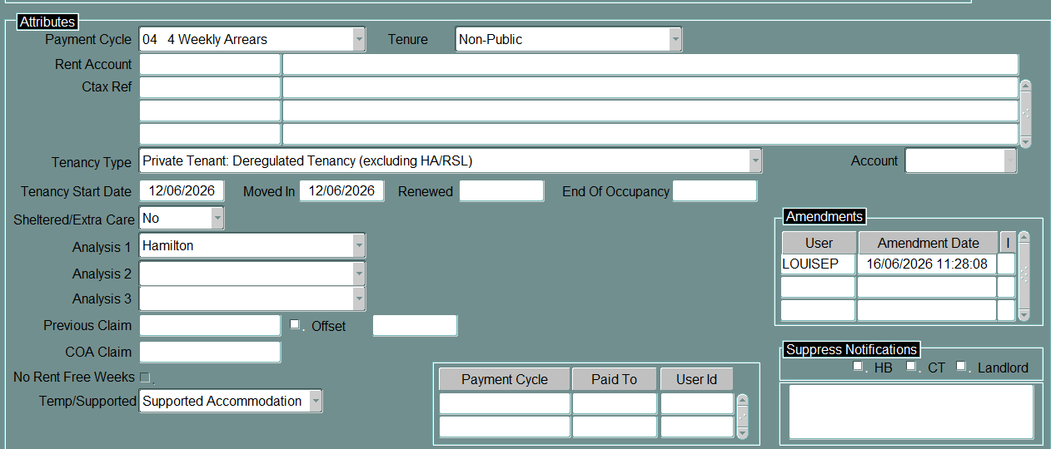

9. Claim Basis

9.1 Tick the ‘Supported Accommodation’ box and enter the description as ‘SA: Homeless in need of support’.

9.2 New Claim
The following information should be loaded for the new claim.

- The change type is ‘New Claim’.
- Enter the relevant ‘Date of Claim’ and ‘Start Date’. If the claimant has just moved into the accommodation, the date of claim will be the date the ‘occupancy agreement’ started and the start date will be the same date (if the HB application has been received within the same week).
- Lodge a claim ID for HB.
- Enter an attributes description of ‘SA: Homeless in need of support’ as this is required for any RO referrals.

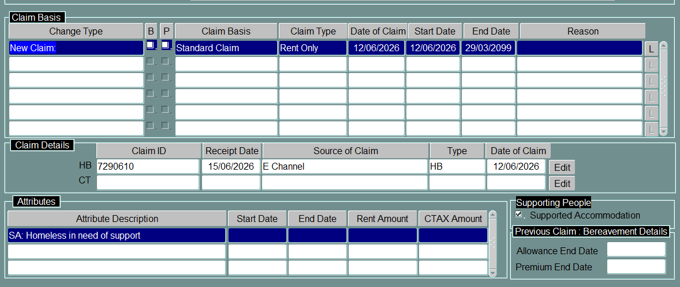

9.3 Change of Address
The following information should be loaded for the change of address.

- The change type is ‘Change of Address’.
- The start date is the date the claimant moved into the accommodation.
- Select the claim ID for HB.
- Enter an attributes description of ‘SA: Homeless in need of support’ as this is required for any RO referrals.

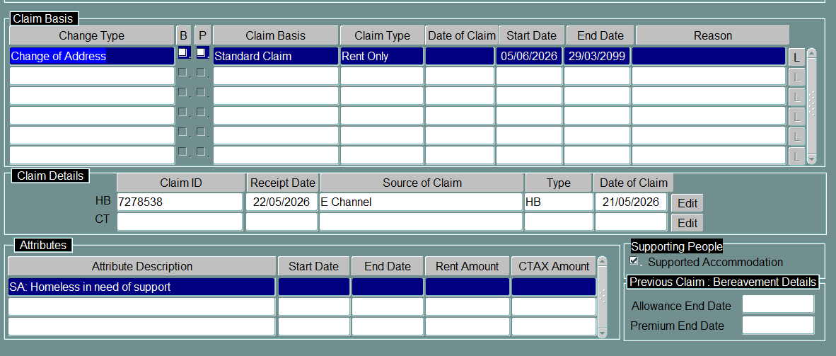

9.4 Process the claim in line with the new claims/change of address procedure. The screens that follow show what information should be loaded which is specific to Willow Gate.
10. Tenancy Details – Part 1

10.1 The following information should be loaded on the tenancy details screen:

- Enter the Landlord Code as 7909037 and tab along. The Landlord Name and Address will automatically populate in the relevant fields.
- Enter the Tenancy Owner/Type/Accommodation as detailed below. It is important that you ensure the accommodation is ‘Exempt Accommodation’.

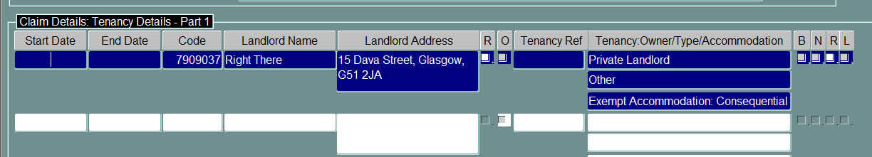

11. Tenancy Details – Part 2

11.1 The following information should be loaded on this screen:

- Tenancy Type – The Tenancy Type is ‘Deregulated Private Tenancy’
- Referred Status – A referral is always ‘Required’ regardless of whether you are issuing a referral to the Rent Officer or not
- Claimant Type – This will be Standard unless the claimant is single and under the age of 35. In these cases, it is Standard (exempt – rough sleeper).
- Charges Frequency – This is always ‘Weekly’
- Tenancy Period – This is ‘Less than a year’ as these tenancies are always let short term and have daily rent charges
- Benefit Scheme – This must be loaded as ‘Old Scheme: Pre January 1996 (Exempt Accommodation) to allow the system to pay the correct HB
- Specified (Excluding ‘Exempt’ Accom – This should be ‘No’ as you cannot select a specified category if you have already selected that it is Supported Exempt
- Specified Short Term Accom – This should be ‘Yes’ as Willow Gate tenancies are always let on a short-term basis
- Exemption from Rent Restriction – Select ‘Pre 1996 Tenancy: Vulnerable Group’
- Payee – This should always be ‘Landlord’ and the reason ‘Claimant Request/Does Not Object’ or ‘claimants interest’. This is due to the short nature of stays most claimants will experience. The landlord creditor reference and payment mode will be automatically loaded when you select landlord as the payee

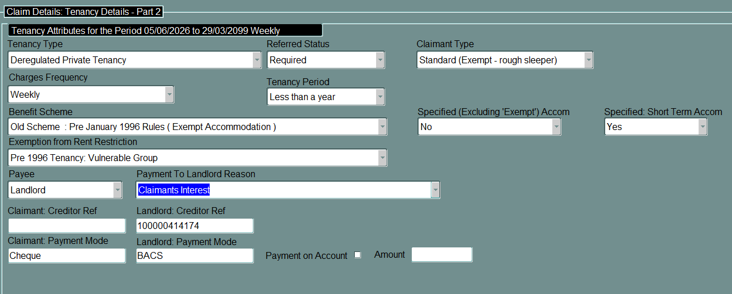

11.2 The system will display a warning message because of the Benefit Scheme selected. You should click on ‘continue’.
12. Tenancy Details – Part 3

12.1 Rooms 1-12 (Hostel Dwelling)
The following information should be loaded on this screen.

- Accommodation Type – This is ‘Hostel’.
- Dwelling Category – This is ‘One Room’.
- Room Usage – This must be loaded as per screen print below to allow the Rent Officer to make a decision on the maximum rent. They will refuse to do a new determination without this information.
- Rent Charges – The full contractual rent and breakdown of eligible charges should be loaded in line with the period the claim covers.

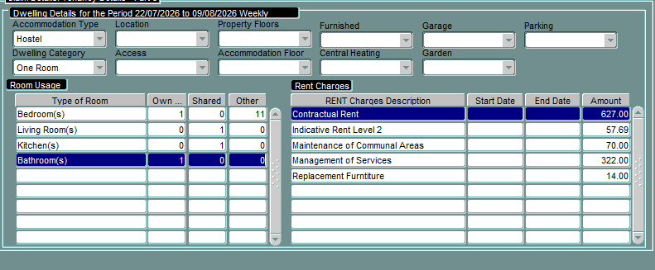
Room details must be loaded as this is required for the Rent Officer to determine the reasonable rent for the property

12.2 Family Suites 1-2 (bedsit)
The following information should be loaded on this screen.

- Accommodation Type – This is ‘Room(s)’.
- Dwelling Category – This is ‘One Room self-contained’.
- Room Usage – This must be loaded as per screen print below to allow the Rent Officer to make a decision on the maximum rent. They will refuse to do a new determination without this information.
- Rent Charges – The full contractual rent and breakdown of eligible charges should be loaded in line with the period the claim covers.
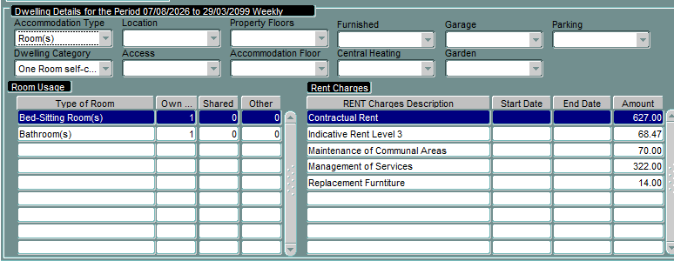
Room details must be loaded as this is required for the Rent Officer to determine the reasonable rent for the property

12. Tenancy Details – Part 3 (cont/d)

12.3 Family Suite 3 (self-contained)
The following information should be loaded on this screen.

- Accommodation Type – This is ‘Room(s)’.
- Dwelling Category – This is ‘One Room self-contained’.
- Room Usage – This must be loaded as per screen print below to allow the Rent Officer to make a decision on the maximum rent. They will refuse to do a new determination without this information.
- Rent Charges – The full contractual rent and breakdown of eligible charges should be loaded in line with the period the claim covers.
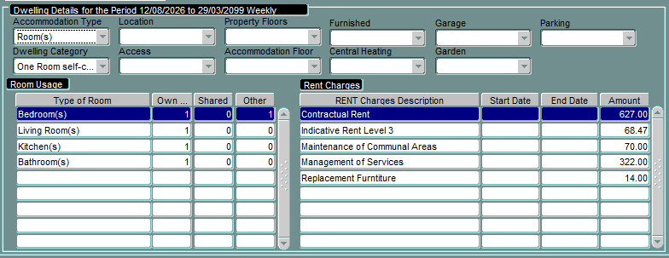
Room details must be loaded as this is required for the Rent Officer to determine the reasonable rent for the property

13. Loading the Rent Officer referral details

13.1 There is no need to refer the claim to the Rent Officer as a determination will already be in place. A 52-week referral will be sent at the relevant time.

13.2 There is one RO determination for rooms 1-12 as this part of the accommodation is classed as a hostel.

13.3 There are 3 family suites that all have their own individual RO determination. Family suites 1 and 2 are classed as bedsits and family suite 3 is a one bed self-contained room.

- Rooms 1-12 that are room only
- Family Suites 1-2 which are self-contained bedsits
- Family Suite 3 which is self-contained (has a separate bedroom)

13.4 The ‘rent and rent officer referral details’ desk aid details the RO determinations.

13.5 To search for any existing Rent Officer determinations, click on the down arrow for ‘All Referrals for Dwelling’ in the tenancy referral details screen. This will list all referrals for that unit.

  - If the current determination matches, select this to assess the HB claim and ensure the ‘Use’ box is ticked.
  - If the current determination does not match, create a new referral and load the relevant details.

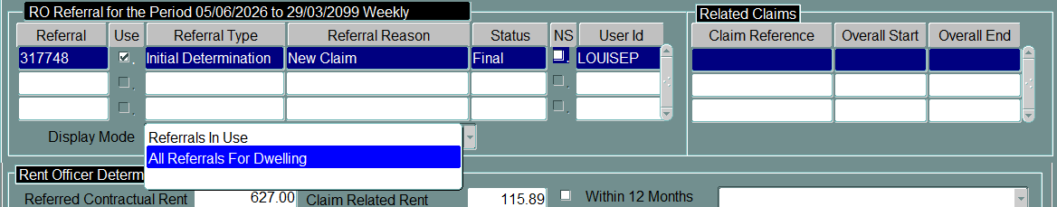
14. Calculation Screen

14.1 The calculation screen will show the amount of HB entitlement. This will be based on the claimant’s income.

14.2 Even when the Rent Officer determination is less than the eligible rent, the claimant can be awarded HB based on the eligible rent amount. The difference in the award of HB between the Rent Officer determination and the eligible rent is paid as a ‘vulnerable’ award and this attracts less HB subsidy.

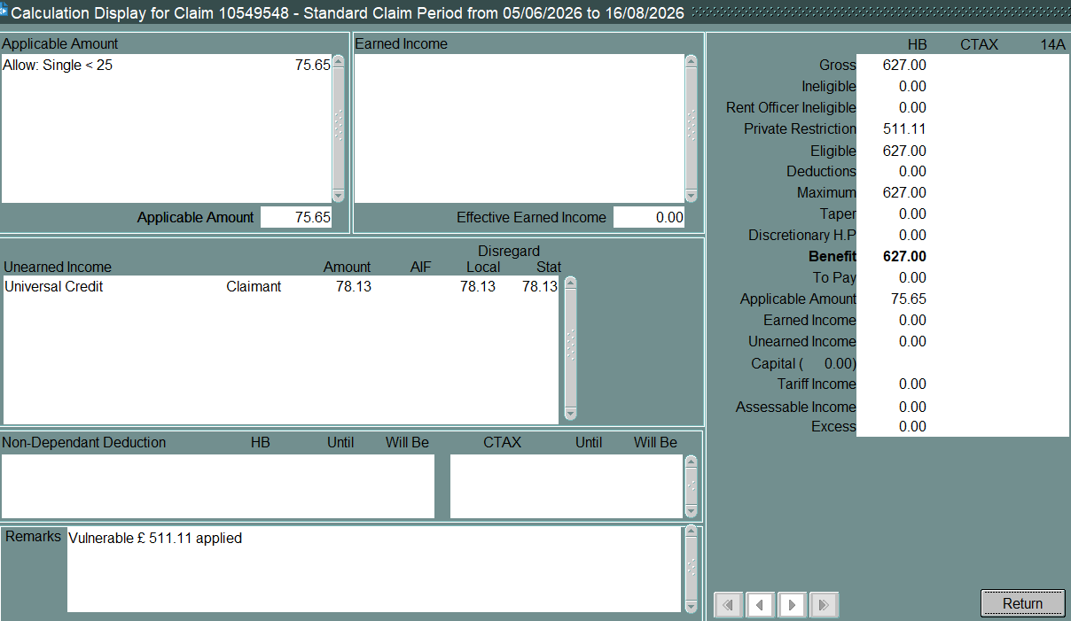

15. Retrospection screen

15.1 Any retrospection to be allocated for HB will be split between a ‘Private’ and ‘Vulnerable’ award. The reason should be ‘Underpayment’ for both.

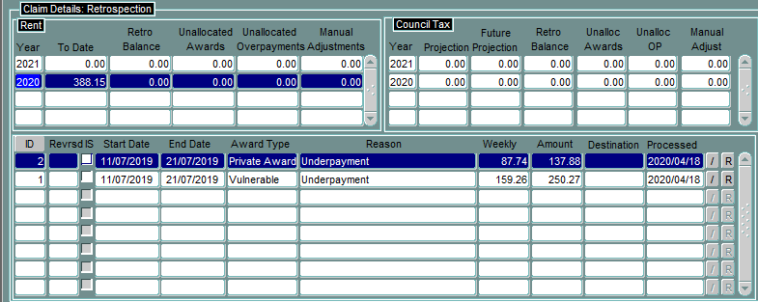

15.2 Process the remainder of the claim following normal processes.

16. Further information

16.1 Information on Rent Officer referrals and determinations can be found in the Rent Officer Referral process procedure.

16.2 Information regarding UC nil awards can be found in the UC Nil Awards and Housing Benefit procedure

16.3 If you have any other queries regarding this procedure please contact Policy.

Record of Amendments

Date | Amendment Made | Reason for amendment | TL Update included in (if applicable) | Procedure Number
June 2026 | New procedure | Willow Gate opened on 01/06/2026 and was new emergency accommodation |  | 26.01
August 2026 | Updated procedure to include process for family suites 1-3 | Willow Gate family suites opened on 28/07/2026 for occupancy |  | 26.02

